**VIETNAM NATIONAL UNIVERSITY – HOCHIMINH CITY**

**INTERNATIONAL UNIVERSITY**

**SCHOOL OF ELECTRICAL ENGINEERING**



**IOT-BASED APPLICATIONS FOR WATER**

**RESOURCE MONITORING SYSTEM**

**BY**

**NGUYỄN TRUNG TÍN**

**EEACIU19063**

A THESIS submitted to the School of Electrical Engineering

in partial fulfillment of the requirements for

the degree of Bachelor of Electrical Engineering

Ho chi minh city, vietnam

June 2025

**IOT-BASED APPLICATIONS FOR WATER**

**RESOURCE MONITORING SYSTEM**

BY

**NGUYỄN TRUNG TÍN**

**EEACIU19063**

Under the guidance and approval of the committee, and approved by its members, this thesis has been accepted in partial fulfillment of the requirements for the degree.

Approved by:

________________________________   
Chairperson

________________________________  
Committee member

________________________________Committee member

________________________________  
Committee member

________________________________  
Committee member

________________________________  
Committee member

# HONESTY DECLARATION

My name is Nguyễn Trung Tín. I would like to declare that, apart from the acknowledged references, this thesis either does not use language, ideas, or other original material from anyone; or has not been previously submitted to any other educational and research programs or institutions. I fully understand that any writings in this thesis contradicted to the above statement will automatically lead to the rejection from the EE/AC program at the International University – Vietnam National University Ho Chi Minh City.

Date: 10/06/2025

Nguyễn Trung Tín

# TURNITIN DECLARATION

Name of Student: Nguyễn Trung Tín

Date:

Advisor Signature Student Signature

Vương Quốc Bảo Nguyễn Trung Tín

__________________ __________________

Date: 10/06/2025 Date: 10/06/2025

# ACKNOWLEDGEMENT

It is with deep gratitude and appreciation that I acknowledge the professional guidance of Dr. Vương Quốc Bảo. His constant encouragement and support helped me to achieve my goal. I would like to express our sincere gratitude to all the individuals who have contributed valuable knowledge to the success and completion of this capstone. Firstly, I would like to express my appreciation to my advisor, Dr. Vương Quốc Bảo for his constructive feedback, encouragement, and guidance in completing this project with his valuable experience. Dr. Vương Quốc Bảo’s professional attitude and working style are an excellent model for us to follow. Secondly, I would also like to thank the professors, doctors, and masters of the Department of Electrical Engineering for imparting valuable knowledge to us. Furthermore, I would like to thank our friends, colleagues, and family for their unwavering support and valuable advice.

# TABLE OF CONTENTS

HONESTY DECLARATION 0

TURNITIN DECLARATION 1

ACKNOWLEDGEMENT 2

TABLE OF CONTENTS 3

LIST OF TABLES 6

LIST OF FIGURES 7

ABBREVIATIONS AND NOTATIONS 9

ABSTRACT 10

CHAPTER I. INTRODUCTION 11

1. 1. Theoretical background 11

1. 1. 1. The importance of water resources and current challenges in Viet Nam 11

1. 1. 2. IoT applications in daily life 12

1. 1. 3. The reason for choosing the topic: Iot applications on water quality monitoring system 13

1. 2. Goals and objectives 14

1. 2. 1. Goal 14

1. 2. 2. Objectives 14

1. 3. The structure of the thesis 14

CHAPTER II. DESIGN SPECIFICATIONS AND ENGINEERING STANDARDS 15

2. 1. Design Specifications 15

2. 1. 1. System overview 15

2. 1. 2. Functional requirements. 15

2. 1. 3. Wifi standard 16

2. 1. 4. Cellular Communication Standard (4G LTE) 16

2. 2. Engineering Codes and Standards 16

2. 3. Realistic constraints 17

CHAPTER III. PROJECT MANAGEMENT 18

3. 1. Budget and Cost Management Plan. 18

3. 2. Project schedule 19

3. 3. Resource Planning 19

CHAPTER IV. LITERATURE REVIEWS 20

4. 1. Existing IoT based water quality monitoring systems. 20

4. 1. 1. First article: Design & Implementation of Water Quality Monitoring & Notification System [9]. 20

4. 1. 2. Second article: Design and Implementation of a Smart Water Monitoring System (IoT) Using Arduino Microcontroller [10]. 22

4. 1. 3. Third article: Real-time Water Quality Monitoring and Notification System for Aquaculture [11] 24

4. 2. Proposed methodology for this senior project. 25

CHAPTER V. METHODOLOGY 27

5. 1. Flow chart 27

5. 2. Hardware design. 29

5. 2. 1. Temperature sensor. 29

5. 2. 2. pH sensor. 30

5. 2. 3. Turbidity Sensor. 31

5. 2. 4. TDS sensor (Total Dissolved Solids) 32

5. 2. 5. Ultrasonic sensor. 33

5. 2. 6. Flow Sensor and DC pump 34

5. 2. 7. Wifi module. 35

5. 2. 8. 4G module. 36

5. 2. 9. GPS module 36

5. 2. 10. Power Supply. 37

5. 3. Software design. 38

5. 3. 1. Drawing the schematic. 38

5. 3. 2. Blynk. 38

5. 4. Proposed model 39

CHAPTER VI. EXPECTED RESULTS 41

6. 1. Results 41

6. 1. 1. Hardware design. 41

6. 1. 2. Software design. 42

6. 1. 3. Evaluate the system performance in different environments. 46

6. 1. 4. Flow rate measurement results 52

6. 1. 5. Warning system test results. 54

6. 2. Discussions 56

CHAPTER VII. CONCLUSIONS AND FUTURE WORK 57

7. 1. Conclusions. 57

7. 2. Future work. 57

CHAPTER VIII. BUSINESS, SOCIAL AND ETHICAL CONSIDERATIONS 59

8. 1. Business considerations 59

8. 2. Social considerations 59

8. 3. Ethical considerations 59

REFERENCES 61

APPENDICES 63

# LIST OF TABLES

Table 2. 1 Engineering Codes and Corresponding Standards 16

Table 2. 2 Realistic Constraints 17

Table 3. 1 Table of Estimated Costs. 18

Table 6. 1 pH correction package specifications 47

Table 6. 2 Number of pulses measured per liter in 10 calibration runs 53

# LIST OF FIGURES

Figure 3. 1Project schedule 19

Figure 4. 1 Block diagram showing connections of all components **[9]** 21

Figure 4. 2 Prototype of water quality monitoring & notification system **[9]** 21

Figure 4. 3 Block diagram of the project **[10]** 22

Figure 4. 4 Flow chart diagram of the project **[10]** 23

Figure 4. 5 Image of the final project work **[10]** 24

Figure 4. 6 Conceptual Diagram of Water Quality Monitoring and Notification System **[11].** 25

Figure 4. 7 The major components of the system **[11]** 25

Figure 5. 1 Block diagram of the system. 27

Figure 5. 2 System flowchart of the IoT-Based Water Resource Monitoring System 29

Figure 5. 3 Dallas temperature sensor (DS18B20) 30

Figure 5. 4 Analog PH sensor 30

Figure 5. 5 Turbidity sensor. 32

Figure 5. 6 TDS sensor 32

Figure 5. 7 Classification of TDS levels in water (ppm) **[14]** 33

Figure 5. 8 Ultrasonic sensor (HC-SRF04). 34

Figure 5. 9 YF-S401 sensor 34

Figure 5. 10 Pump motor 385 12V DC 35

Figure 5. 11 The ESP8266 Wi-Fi module. 35

Figure 5. 12 A7682S module. 36

Figure 5. 13 37

Figure 5. 14 DC Voltage Reduction Circuit LM2596. 37

Figure 5. 15 Schematic of the system on Proteus software. 38

Figure 5. 16 Proposed model 39

Figure 6. 1. Hardware system. 41

Figure 6. 2 Blynk application interface on smartphone. 42

Figure 6. 3 LCD display 43

Figure 6. 4 4G module in operating state. 43

Figure 6. 5 SIM connection success notification and sensor data. 44

Figure 6. 6 ESP32 module successfully connects to the Wi-Fi network. 44

Figure 6. 7 GPS module connected successfully 44

Figure 6. 8 Real time GPS coordinates and location link displayed on Blynk app 45

Figure 6. 9 GPS link from blynk app and location on google maps 45

Figure 6. 10 Blynk application interface displaying sensor parameters. 46

Figure 6. 11 pH correction package. 47

Figure 6. 12 Hardware system when operating with low pH water samples. 48

Figure 6. 13 Blynk interface shows pH measurement result is 4.02 with other indicators 48

Figure 6. 14 The litmus test results showed that the pH was at 4. 49

Figure 6. 15 Hardware system when operating with pH = 6.96 water samples. 49

Figure 6. 16 Blynk interface shows pH measurement result is 6.85 with other indicators 50

Figure 6. 17 The litmus test results showed that the pH was at 6 50

Figure 6. 18 Hardware system when operating with high pH water samples 51

Figure 6. 19 Blynk interface shows pH measurement result is 8.81 with other indicators 51

Figure 6. 20 The litmus test results showed that the pH was at 10 52

Figure 6. 21 LCD display with WF = 1.21 l/m 53

Figure 6. 22 Turbidity alert on Blynk 54

Figure 6. 23 SMS alert with turbidity: 619 NTU 54

Figure 6. 24 Distance alert on Blynk 55

Figure 6. 25 SMS alert with distance: 200 55

# ABBREVIATIONS AND NOTATIONS

GSM: Global System for Mobile Communications

GPRS: General Packet Radio Service

TDS: Total dissolved solids

NTU: Nephelometric Turbidity Units

Ppm: parts per million

# ABSTRACT

Water is the most precious natural resource for all humans not only in living but also in manufacturing. However, water pollution and overexploitation have seriously affected the quality and availability of water, becoming a major problem globally. Water quality detection plays an important role in water pollution warning, water source pollution detection as well as water source diagnosis and treatment. The Internet and related technologies have created opportunities to improve water quality monitoring, while reducing the cost of measuring parameters such as temperature, turbidity, pH... For the above reasons, in this thesis report, we present an IOT application in water quality monitoring. The system aims to support proactive water management by detecting early signs of pollution or irregularities in water availability. The methodology involves the integration of multiple environmental sensors including temperature, turbidity, pH level, total dissolved solids (TDS), and flow rate connected to a microcontroller. Data is collected, processed and displayed on LCD and simultaneously transmits warnings to users when there is an abnormality as a message via mobile using 4G module (A7682S). The system leverages the Blynk Internet of Things (IoT) platform for real-time remote visualization and warning notification. The implemented system was tested under different conditions representing acidic, neutral, and alkaline environments. The results demonstrate that the system provides accurate sensor readings, timely alerts. In conclusion, the proposed IoT-based water resource monitoring system is a reliable, low-cost, and scalable solution that can support household water resource monitoring and management.

**Keywords:** Microcontroller, sensors, water quality monitoring, GSM Module, LTE sim

# INTRODUCTION

In this chapter, there are three main parts which are theoretical background, goal and objectives, and structure of the senior report.

## Theoretical background

This section will be divided into 3 small parts including: first is the importance of water resources and current challenges in Viet Nam, the second is IoT applications in daily life and the reason for choosing the topic.

### The importance of water resources and current challenges in Viet Nam

Water covers ¾ of the earth and is a valuable resource for human life. 70% of the Earth's surface is covered by water, but only 2.5% of the world's water is fresh water, while 97.5% is ocean water **[1]**. Of this, 0.3% of the world's fresh water is in rivers and lakes; 30% is groundwater, the rest is on glaciers and icebergs **[1]**. 70% of the world's water is used for agriculture, 22% for industry and 8% for daily life **[2]**.

Industrialization, modernization, and climate change are putting pressure on both the quality and quantity of water resources. Water depletion, increased demand for clean water, and declining water quality are challenges facing humanity. Currently, more than 2.6 million people worldwide do not have access to basic sanitation and nearly 1 billion people do not have access to clean water **[2]**. Every 20 seconds, a child dies from diseases related to lack of clean water and adequate sanitation **[2]**. A recent report by the World Bank estimates that by 2030, human demand for water will exceed supply by 40% **[1].**

Currently, many large cities, typically Hanoi and Ho Chi Minh City, are still lacking clean water for daily life. Groundwater resources are being exploited uncontrollably, and drilling wells to get underground water is rampant, not only causing loss and waste but also potentially polluting that water source. Furthermore, due to not fully understanding the importance of water resources, all over the country, there are landfills, burial sites, and waste treatment facilities that are not carried out in accordance with regulations and environmental protection procedures, allowing leachate to seep into underground water sources and overflow into saltwater sources.

With the increasingly serious scarcity and pollution of water resources, the need for monitoring and managing water quality has become more urgent than ever. Current challenges require advanced technological solutions to monitor and protect precious water resources. Therefore, the application of water quality monitoring technology, especially IoT systems with smart sensors, not only helps to measure accurately but also provides real-time data, supporting timely detection and handling of water pollution and depletion problems. This solution will be the key to protecting water resources, ensuring safety and quality of life for the community.

### IoT applications in daily life

The development of the Internet of Things has a strong impact on production, business, life and society in many fields: infrastructure management, healthcare, construction and automation monitoring **[3]**. The Internet of Things (IoT) is a rapidly expanding computer trend that enables objects or gadgets linked to the internet to have the ability to gather, process, and share information **[4]**. The internet of things is known as a technology that has demonstrated its existence as a network of machines or gadgets that can communicate with one another **[4]**.

Over the past few years, IoT has become one of the important technologies. IoT helps people live and work smarter, as well as be completely proactive in life. In the application of water quality monitoring, IoT plays an important role by providing automatic and intelligent monitoring solutions. A wireless sensor network-based real-time drinking water water quality monitoring system was introduced in **[5]**. The system sent the user an SMS alert with the water quality metrics, including temperature, turbidity, and pH, using a Zigbee module. The identical parameters from **[5]** were examined in **[6]**, relayed to the user via an XBee wireless module, and shown on the LCD. When the parameters are dangerous, a buzzer will sound an alert. A real-time mobile water temperature monitoring system that could help aquaculture farmers improve their operations was described in **[7]**. The Raspberry Pi served as the microcontroller, and it was connected to the mobile device through the internet. Finally, a survey of water quality monitoring with wireless sensor networks (WSN) was provided in **[8]**. The results show how dependent the project is on the mobile network.

### The reason for choosing the topic: Iot applications on water quality monitoring system

The International Standard Organization defines water quality monitoring as a process for collecting, measuring, and further documenting or indicating different water features, with the objective of evaluating compliance with specified water quality objectives **[4]**. Water quality describes the overall biological, physical, and chemical composition of the water. Thus, evaluating drinking water quality requires monitoring various physical, chemical, and biological parameters. This is where the application of IoT in water quality monitoring becomes crucial, allowing for continuous, accurate, and efficient data collection and analysis, providing the basis for informed decision-making in water management.

In this project, a device was developed to measure water quality indicators, including pH, temperature, turbidity, total dissolved solids (TDS), and flow rate. with higher accuracy and efficiency than existing instruments. The device integrates multiple environmental sensors connected to an Arduino microcontroller, an ESP8266 module, and 4G module allowing real-time data transmission to mobile devices via the Blynk IoT platform and SMS. Users can easily monitor water quality on their smartphones and receive immediate alerts when abnormalities are detected. Thanks to the ability to continuously collect data and send real-time notifications, the system helps improve the efficiency of water resource monitoring, while reducing costs and optimizing the handling process when problems occur.

## Goals and objectives

### Goal

Design and development of an IoT-based system to monitor water resources by measuring temperature, pH, turbidity, total dissolved solids (TDS), and flow rate. Sensor data is collected via a microcontroller, sent to a mobile app through Wi-Fi, and abnormal values trigger SMS alerts.

### Objectives

1. Review the existing techniques that use IoT to monitor water quality.
2. Design and implement an IoT-based system to monitor water resources by measuring temperature, pH, turbidity, total dissolved solids (TDS), and flow rate. The data will then be sent to the user via the blynk platform and sms messagess.
3. Evaluate the system performance in different environments.

## The structure of the thesis

The content of this thesis is divided into seven chapters. The chapter I provides about theoretical background, and it also presents the goals and objectives of the senior. The second chapter is design specifications and standards. The third chapter provides a budget and cost management plan, a project management plan, tasks to be performed, and specific timelines for each task, all displayed in a Gantt chart. Next are the references related to our project, providing knowledge and solutions for developing the water quality monitoring system presented in Chapter IV. The fifth chapter provides the methodology for achieving the objectives. Chapter VI presents the results. Finally, chapter 7 discusses conclusions, implications, strengths, weaknesses and effectiveness of the system and future development prospects.

# DESIGN SPECIFICATIONS AND ENGINEERING STANDARDS

This chapter provides a detailed description of the hardware and software design of the IoT-based water resource monitoring system. Establish a clear framework for the system design, including architectural structure, functional requirements, and engineering constraints to ensure reliable and efficient operation. The system uses microcontrollers, various sensors to collect data, connects to WiFi and 4G modules, and transmits information to users over the network.

## Design Specifications

### System overview

The water quality monitoring system uses Arduino UNO and ESP8266 to connect temperature, pH, turbidity, total dissolved solids (TDS), flow rate, and geographic location sensors to WiFi and 4G module. The data will be transmitted to the Blynk application, where users can monitor the parameters in real time.

The index sensors include: DS18B20 sensor (temperature measurement), pH sensor, turbidity sensor, total dissolved solids (TDS), flow rate sensor.

The 4G module (A7628S) is used for communication via 4G network, ensuring monitoring capability in the absence of WiFi.

### Functional requirements.

* Measure key water parameters: temperature, pH, turbidity, TDS, and flow rate.
* Collect data using an Arduino-based microcontroller.
* Display real-time readings on a local LCD screen.
* Transmit sensor data to the Blynk mobile application via Wi-Fi (ESP8266)
* Send SMS alerts via the A7682S 4G LTE module when abnormal values are detected.

### Wifi standard

The system uses the ESP8266 WiFi module, supporting the IEEE 802.11 b/g/n WiFi standard. This WiFi standard allows data transmission at speeds up to 150 Mbps in the 2.4 GHz band. This is a popular standard and is suitable for IoT applications thanks to its stable connection and good coverage in indoor and outdoor environments. In addition, this module supports security protocols such as WPA/WPA2, ensuring the safety of transmitted data.

### Cellular Communication Standard (4G LTE)

The system uses the A7682S 4G LTE module for mobile communication, which complies with the 3GPP LTE standards. LTE (Long-Term Evolution) provides higher data rates, lower latency, and better coverage compared to traditional GSM based modules. The A7682S module supports a variety of frequency bands and operates on the 4G network infrastructure, allowing data to be transmitted efficiently and reliably, especially in areas without Wi-Fi connectivity. This standard ensures stable and secure data communication for sending SMS alerts and supporting remote monitoring in IoT applications.

## Engineering Codes and Standards

Table 2. 1 Engineering Codes and Corresponding Standards

|  |  |  |
| --- | --- | --- |
| Element/Product/System | Engineering Standards | Comments |
| Electrical Safety | IEC 61140: Protection against  electric shock | Ensure proper insulation and grounding in circuit design |
| Embedded Systems Design | IEEE 1474: Guidelines for microcontroller-based systems | Guides integration of Arduino, ESP8266, and A7682S module |
| Wireless Communication | IEEE 802.11 (Wi-Fi), 3GPP LTE (4G) standards | Governs ESP8266 Wi-Fi and A7682S 4G module communication |
| Sensor Calibration and Accuracy | ISO 15839: Water quality online sensors for water monitoring | Ensures proper setup and interpretation of pH, TDS, turbidity sensors |
| Environmental Data Handling | IEEE 1451: Smart sensor interface for transducers | Standardizes the way sensors communicate with the microcontroller |

## Realistic constraints

Table 2. 2 Realistic Constraints

|  |  |
| --- | --- |
| Area | Realistic Constraints |
| Economic | Low-cost components such as Arduino UNO, ESP8266, and basic sensors are used to reduce total cost. |
| Environment | The system is intended to be used in varied environmental conditions, requiring water-resistant casing and stable operation under temperature/humidity fluctuations. |
| Social | Provides access to water quality information for households and rural communities, improving awareness and safety. |
| Ethical | Accurate and reliable data collection is ensured to avoid misleading results that could affect health or environmental decisions. |
| Sustainability | Electrical safety measures, such as proper insulation and low-voltage design, are implemented to prevent shock or short circuits. |
| Health and Safety | The system consumes low power and is designed for long-term deployment with minimal maintenance. |
| Manufacturability | Designed with off-the-shelf, widely available components to support ease of assembly and prototyping. |

# PROJECT MANAGEMENT

This chapter shows the project budget, cost management plan, project schedule and resource planning.

## Budget and Cost Management Plan.

Table 3.1 provides a description of how the project costs are managed. Provides detailed information on the costs of all components and equipment required for the project.

Table 3. 1 Table of Estimated Costs.

|  |  |  |  |
| --- | --- | --- | --- |
| Numbers | Component | Amount | Cost |
| 1 | Arduino UNO R3 | 1 | 99.000 VND |
| 2 | ESP8266 (Node MCU) | 1 | 95.000 VND |
| 3 | LCD2004 | 1 | 82.000 VND |
| 4 | 4G module | 1 | 189.000 VND |
| 6 | GPS module | 1 | 200.000 VND |
| 7 | Temperature sensor | 1 | 20.000 VND |
| 8 | pH sensor | 1 | 1.100.000 VND |
| 9 | Turbidity sensor | 1 | 120.000 VND |
| 10 | Ultrasonic sensor | 1 | 30.000 VND |
| 11 | TDS sensor | 1 | 110.000 VND |
| 12 | Flow sensor | 1 | 77.000 VND |
| 13 | Other component |  | 500.000 VND |
| 14 | Other costs |  | 1.000.000 VND |
| 15 | Total |  | 3.622.000 VND |

## Project schedule

The project progress and timeline to achieve the goals and objectives are shown in the gantt chart below

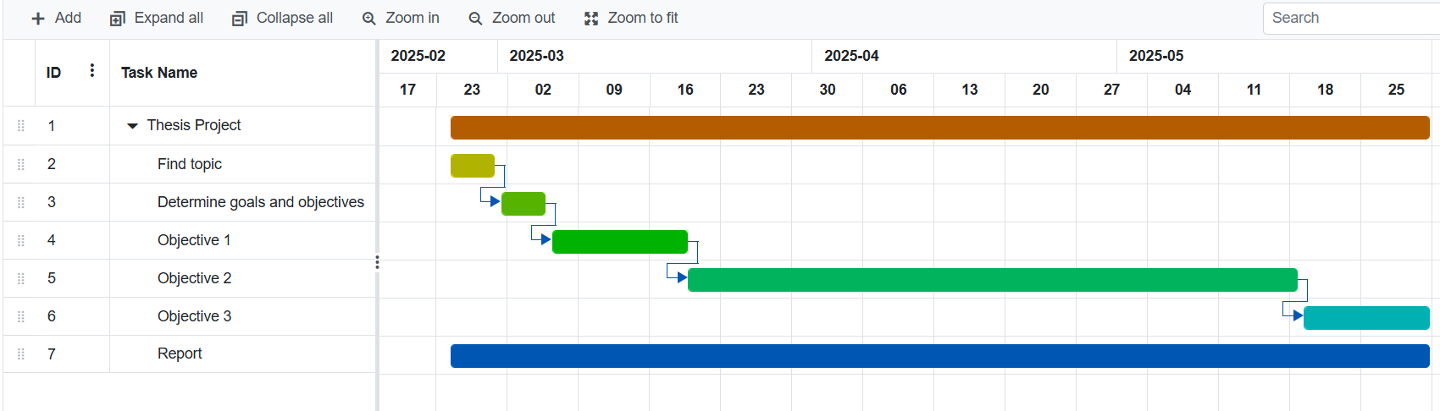

Figure 3. 1Project schedule

## Resource Planning

Hardware resources: The system was built using low-cost components, including Arduino UNO, ESP8266, A7682S, various water quality sensors pH, turbidity, TDS, temperature, flow sensor, GPS module, and a 20x4 LCD.

Software tools: we will use the C programming language. All code will be developed on Arduino IDE software. There are main libraries we use: Wire.h, SoftwareSerial.h, OneWire.h, DallasTemperature.h, LiquidCrystal.h, ESP8266WiFi.h, TimerOne.h, BlynkSimpleEsp8266.h. Proteus was utilized for circuit simulation, and the Blynk platform was used for mobile-based monitoring

# LITERATURE REVIEWS

Based on section **1.2.2** the first objective is to study existing techniques using IoT to monitor water quality. To achieve this objective, we have divided the literature review into two main sections: **4.1** Existing IoT based water quality monitoring systems and **4.2** Proposed methodology to be applied in this senior project. Below are details of each part.

## Existing IoT based water quality monitoring systems.

Recently, with the advancement of Internet Things (IoT), several IoT based solutions have been introduced for water quality monitoring, I found 3 articles on how to develop a system to monitor water parameters.

### First article: Design & Implementation of Water Quality Monitoring & Notification System [9].

This paper presents a low-cost IoT-based solution for real-time water quality monitoring. The system uses sensors to measure pH, turbidity and temperature parameters, integrated with Arduino Mega microcontroller for data collection and processing. The results are displayed locally on the LCD screen and SMS notifications are sent via GSM module (SIM900A), helping users receive instant alerts when parameters are abnormal.

#### Hardware.

The hardware devices used include:

* Turbidity Sensor
* Temperature sensor
* PH sensor
* Ultrasonic sensor
* Arduino Mega Board
* GSM shield module
* LCD display

#### Block diagram and prototype of system.

Figure 4.1 shows the connection diagram of the components.

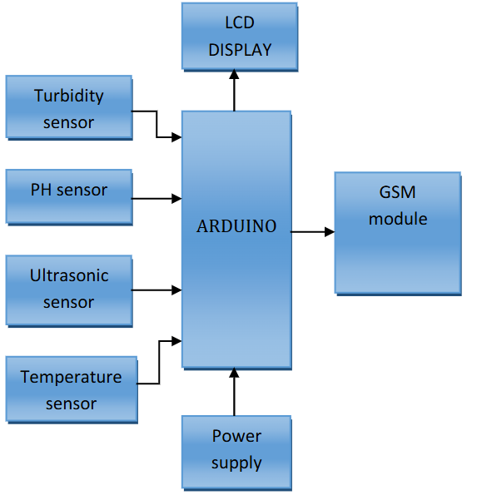

Figure 4. 1 Block diagram showing connections of all components **[9]**

Figure 4.2 is the prototype of the product.

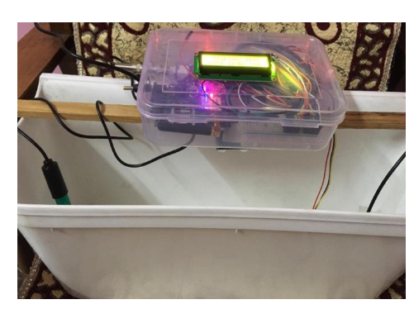

Figure 4. 2 Prototype of water quality monitoring & notification system **[9]**

### Second article: Design and Implementation of a Smart Water Monitoring System (IoT) Using Arduino Microcontroller [10].

This study presents a smart water monitoring system using IoT technology, focusing on real-time measurement of water quality and level. The system integrates multiple sensors, Arduino Mega microcontroller and Cayman IoT platform for data monitoring and visualization.

#### Proposed methodology.

The overall design of the water monitoring system is shown in Figure 4.3**[10]**

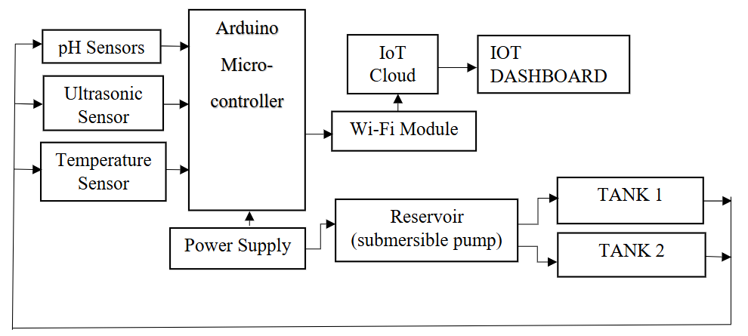

Figure 4. 3 Block diagram of the project **[10]**

The system consists of two tanks and a water reservoir connected, and a 5V DC pump system. Each tank is equipped with an ultrasonic sensor placed on top, which is responsible for monitoring the water level in the tank. When the water in the tank reaches the lowest level, the ultrasonic sensor will send a signal to the Arduino microcontroller to activate the pump, ensuring that water is pumped into the tank. Conversely, when the water reaches the highest level, the sensor will send a signal to turn off the pump, helping to prevent water overflow. The system operates fully automatically, ensuring effective management of the water level in the tanks.

A pH sensor is installed in the reservoir where water is pumped into the two tanks to assess safety for use. The pH value is displayed on the IoT dashboard, and if the pH is out of the neutral range (below 7 is acidic, above 7 is alkaline), the water will need to be filtered. The pH scale ranges from 0 to 14, with 7 being neutral, indicating a balance between acid and alkalinity **[10]**. Additionally, a temperature sensor is placed in the reservoir to measure the temperature of the water as it enters the tank, determining how hot or cold the water is.

The data collected from the sensor, including water level, pH, and temperature, is transmitted to the Cayenne myDevices IoT platform via a Wi-Fi module **[10]**. This platform allows for real-time analysis and visualization of values, helping users monitor and manage water quality effectively.

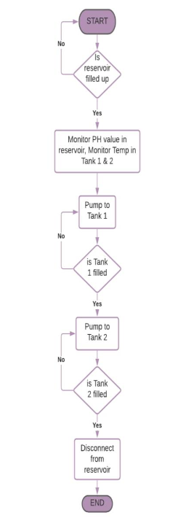Figure 4.4 is a flow chart of the system's operation.

Figure 4. 4 Flow chart diagram of the project **[10]**

#### Hardware.

These are the hardware devices as well as the final product developed in figure 4.5.

* Ph sensor
* Arduino mega
* Esp8266 wifi module
* Temperature sensor
* Ultrasonic sensor

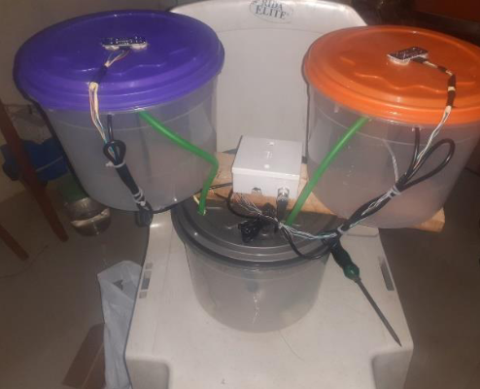

Figure 4. 5 Image of the final project work **[10]**

### Third article: Real-time Water Quality Monitoring and Notification System for Aquaculture [11]

This paper presents a water quality monitoring system that can automatically adjust four types of water quality parameters including temperature, potential hydrogen (pH) level, turbidity, and dissolved oxygen. The system uses Arduino Nano as the main controller, combined with NodeMCU (ESP8266) to transmit data via Firebase Realtime Database **[11]**. A mobile application is developed using React Native, supporting real-time value monitoring, receiving notifications when the indicators are out of standard, and providing appropriate action suggestions. The main purpose of the research is to develop a smart farm model using IoT to raise fish at high density in a closed system to be environmentally friendly and sustainable **[11]**.

#### Hardware design.

Key features include:

* Monitoring and reporting abnormal values.
* Customizing water quality thresholds.
* Displaying historical data in a visual graph.

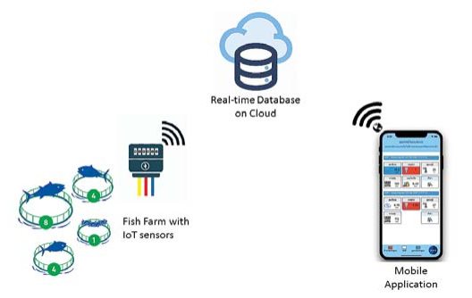Figure 4.6 below illustrates the conceptual framework and main components of the system

Figure 4. 6 Conceptual Diagram of Water Quality Monitoring and Notification System **[11].**

Figure 4.7 shows the main components of the hardware system.

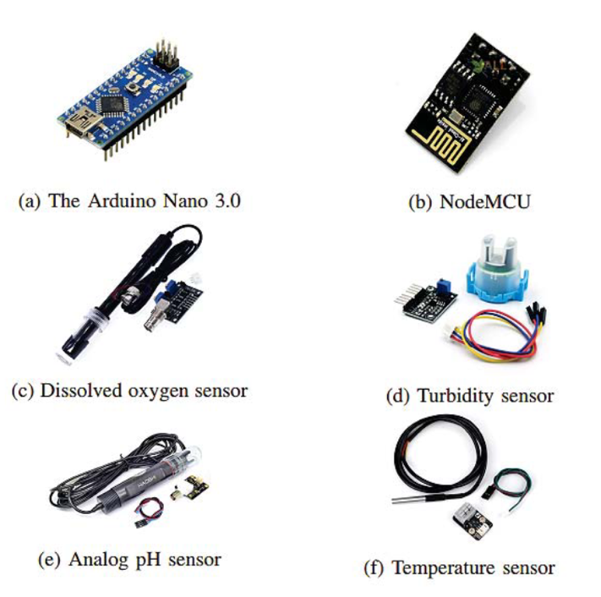

Figure 4. 7 The major components of the system **[11]**

## Proposed methodology for this senior project

Through the study of related documents in section **4.1**, many water quality monitoring systems have been developed based on IoT technology. Most of them use sensors to measure important parameters such as temperature, pH, dissolved oxygen and turbidity, combined with connection modules to transmit data in real time or over the network. The study by Katole and colleagues(section **4.1.1**)used Arduino Mega, temperature, pH, turbidity sensors, and GSM module to collect, analyze water quality data and send SMS notifications to users. This system allows real-time monitoring and alerts when parameters exceed safety thresholds. Similarly, Ogundele Joshua’s research (section **4.1.2**) focused on monitoring water quality and water levels in tanks, combined with the Cayenne IoT platform to display data via an online dashboard. This research highlights the flexibility and integration of IoT in remote water monitoring, making it easy for users to check important indicators from anywhere. And Jomsuda Duangwongsa’s research (section **4.1.3**) successfully implemented a system using Arduino Nano, NodeMCU (ESP8266) and Firebase Realtime Database to monitor water in aquaculture ponds, providing information directly via a mobile application. These studies are important references for developing the method in my project.

Based on the results and techniques from the above studies, this project applies pH, temperature, turbidity, total dissolved solids (TDS), and flow sensors with an Arduino UNO microcontroller, displays parameters on LCD screen and transmitted via Wi-Fi using the ESP8266 module to the Blynk mobile application. Simultaneously, a 4G LTE communication module (A7682S) is employed to send SMS alerts to users when critical thresholds are exceeded. The difference is the flexible combination of two data transmission methods (WiFi and 4G), allowing the system to operate even without WiFi connection. This not only saves costs but also ensures providing real-time data and warnings when water parameters exceed thresholds.

# METHODOLOGY

Based on the goals and objectives in Chapter I and the analysis results from related studies in Chapter IV, the overall design of the water monitoring system is shown: Figure 5.1

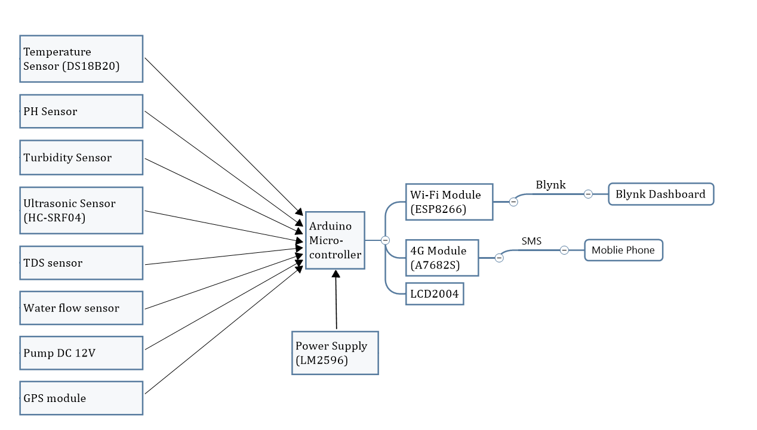

Figure 5. 1 Block diagram of the system.

The methods will be described in detail in this chapter. It is organized into three main sections:

1. Flow chart
2. Hardware design
3. Software design
4. Proposed model

## Flow chart

Figure 5.2 illustrates the flowchart of the IoT-based water resource monitoring system. The process begins with establishing connections between the Arduino UNO microcontroller, all environmental sensors, the ESP8266 Wi-Fi module, and the A7682S 4G LTE module via a hotspot or Wi-Fi connection. Once connections are successfully initialized, the system continuously reads water-related parameters from the following sensors:

* Temperature sensor (DS18B20): Measures the water temperature.
* pH sensor: Detects the acidity or alkalinity of the water.
* Turbidity sensor: Monitors water clarity.
* TDS sensor: Measures the total dissolved solids concentration.
* Flow sensor: Calculates the water flow rate during pumping.
* Ultrasonic sensor (SRF04): Estimates the water level inside the container.
* GPS module: Provides real-time geographical location of the monitoring unit.

The collected analog or digital signals are processed by the Arduino UNO. The sensor readings are then:

* Displayed on a 20x4 I2C LCD for local on-site observation.
* Transmitted to the ESP8266 module and forwarded to the Blynk Cloud for real-time monitoring via a mobile application.

If any measured parameter exceeds its predefined threshold:

A warning is triggered in the Blynk interface by activating a red virtual LED.

Simultaneously, an SMS alert is sent via the A7682S 4G LTE module to a predefined phone number to notify the user about the abnormal condition.

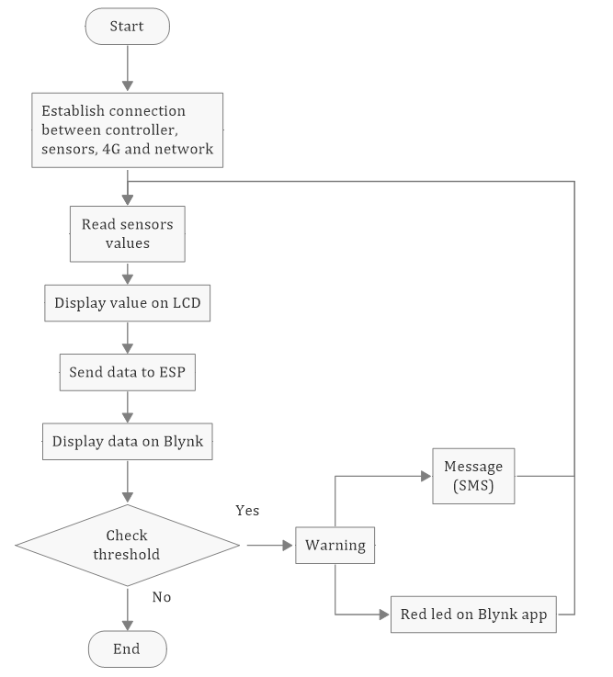

Figure 5. 2 System flowchart of the IoT-Based Water Resource Monitoring System

## Hardware design

The components used in this system are explained below.

### Temperature sensor

The Dallas temperature sensor shown in Figure 5.3 is a 1-wire programmable temperature sensor and measures temperature in the range of -55°C to +125°C with an accuracy of ±0.5°C **[9]**. The sensor has a durable, waterproof design, suitable for harsh environments such as chemical fluids or soil. The DS18B20 only needs one data pin of the microcontroller, in the system connected to pin 12 of Arduino UNO via 1-Wire protocol, Arduino collects temperature data from DS18B20 using the **OneWire.h** and **DallasTemperature.h** libraries.

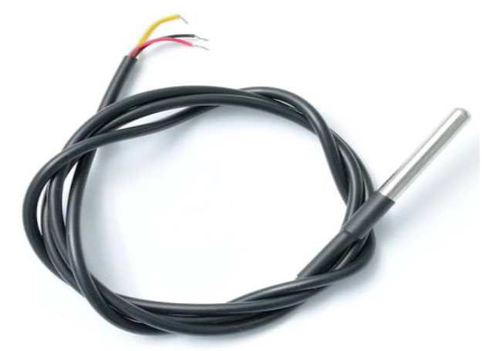

Figure 5. 3 Dallas temperature sensor (DS18B20)

### pH sensor.

pH (potential Hydrogen) is the acidity or alkalinity of water. The pH sensor module in figure 5.4 consists of pH sensor also called as pH probe and a signal conditioning board which gives an output which is proportional to the pH value and can be interfaced directly to any microcontroller **[11]**.

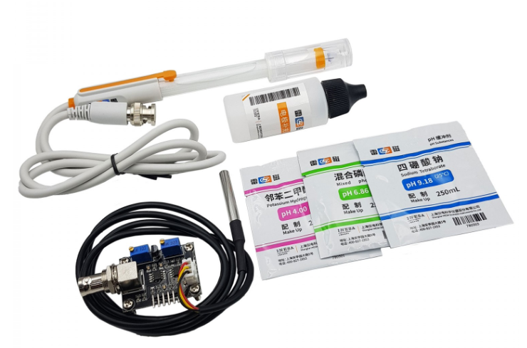

Figure 5. 4 Analog PH sensor

Technical parameters of pH sensor module E-201C bảng 5.1

Table 5. 1 Technical parameters of pH sensor [13]

|  |  |  |
| --- | --- | --- |
| Numbers | Parameters | Values |
| 1 | Power supply | 5VDC |
| 2 | Working current | 5 ~ 10mA |
| 3 | Power consumption | <0.5W |
| 4 | Return signal | Analog |
| 5 | PH measurement range | 0 - 14 pH |
| 6 | Response time | ≤ 5 seconds |
| 7 | Stabilization time | ≤ 60 seconds |
| 8 | Accuracy | ±0.1 pH (at 25°C) |
| 9 | Working temperature range | 0°C – 60°C (best at 20°C) |
| 10 | Working humidity range | 0% – 95% (best at 60%) |
| 11 | Response speed | < 1 minute |
| 12 | Weight | 25g |

The analog signal is connected to the **A0** pin of Arduino UNO. pH value ranges from 0-14, with 0 – 6 as acidic and 8 – 14 as alkaline. Acidic water tastes sour, while alkaline water tastes bitter or soap **[12]**.

### Turbidity Sensor

Turbidity is the darkness or opacity of water due to the presence of many microscopic particles in the water that are invisible to the naked eye, like smoke in the air **[9]**. The turbidity sensor in figure 5.5 can detect water quality by measuring the level of turbidity/opacity in the water. It can detect suspended particles in water by measuring the scattering rate and transmittance, which vary with the amount of total suspended solids in the water. As the total suspended solids increase, the turbidity of the liquid also increases. The scale used by this sensor is Nephelometric Turbidity Units (NTU). In this system, the turbidity sensor outputs an analog voltage that is proportional to the water’s turbidity level. The analog signal is connected to the **A2** pin of Arduino UNO, where it is read and 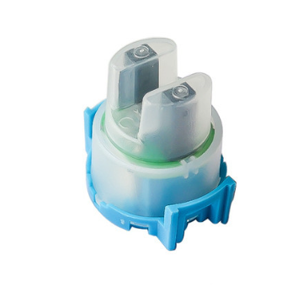processed.

Figure 5. 5 Turbidity sensor.

### TDS sensor (Total Dissolved Solids)

The TDS sensor (figure 5.6) measures the concentration of total dissolved solids in water, with the unit expressed in parts per million (ppm). TDS represents the number of milligrams of dissolved solids present in one liter of water. The higher the TDS value, the greater the concentration of dissolved substances, corresponding to the lower purity of the water. The sensor connects to the Arduino's **A1** analog pin and is processed in real time along with other sensor data.

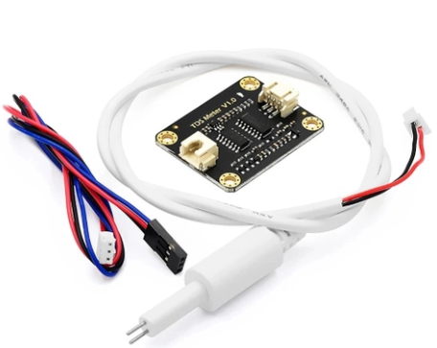

Figure 5. 6 TDS sensor

To better understand the implications of TDS levels on water quality, the figure 5.7 below provides a classification range:

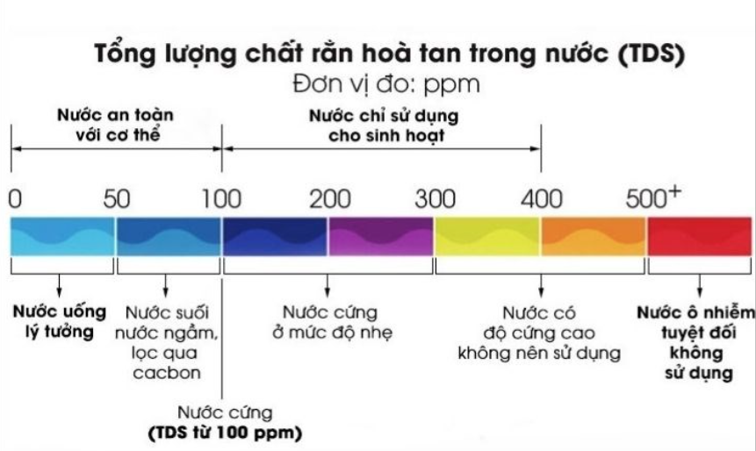

Figure 5. 7 Classification of TDS levels in water (ppm) **[14]**

* 0 – 100 ppm: ideal drinking water, water safe for human.
* 100 – 400 ppm: water for domestic use only
* Above 500 ppm: polluted water, absolutely do not use

Cảm biến kết nối với chân analog A2 của Arduino và được xử lý theo thời gian thực cùng với dữ liệu cảm biến khác.

### Ultrasonic sensor.

The ultrasonic sensor, as shown in figure 5.8 measures distance by transmitting ultrasonic waves and receiving the reflected waves from the target surface. In this system, the sensor is used to monitor the water level in the tank, determining whether it is empty or full. The sensor works by calculating the time taken for the ultrasonic waves to travel to the water surface and return, which is then converted into distance using the speed of sound.

The ultrasonic sensor is connected to the Arduino UNO with two pins:

**Trigger** pin: Sends out the ultrasonic signal (Pin 4 of Arduino UNO)

**Echo** pin: Receives the reflected signal (Pin 5 of Arduino UNO)

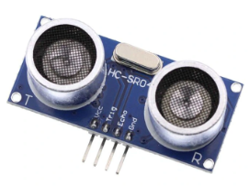

Figure 5. 8 Ultrasonic sensor (HC-SRF04).

### Flow Sensor and DC pump

In this system, the water flow sensor employed is a hall sensor type (figure 5.9), widely used in both residential and industrial applications due to its durability and reliable measurement capability. The sensor typically consists of three main components: a water inlet valve, a turbine-style rotor, and a hall magnetic sensor positioned near the rotor.

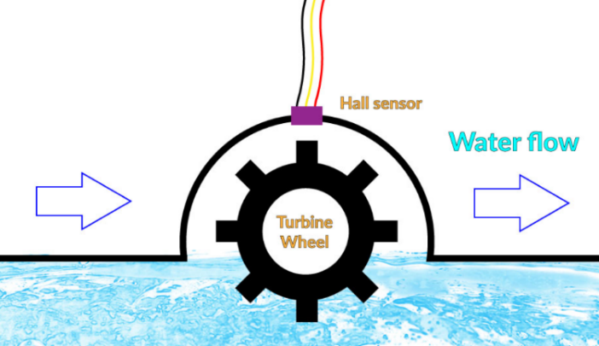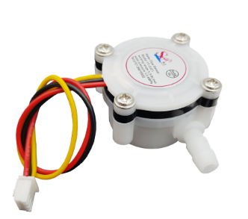

Figure 5. 9 YF-S401 sensor

When water passes through the valve, the water flow rotates the rotor, generating electrical pulses through the change in magnetic field at the Hall sensor location. The higher the flow rate, the higher the frequency of the pulses. These electrical pulses are sent to pin 2 of the arduino.

In addition to the flow sensor, the system also integrates a pump motor with a pumping capacity of 1.5 liters to 2 liters of water per minute operating with a voltage of 12V DC (Figure 5.10),, which is connected to digital pin 9 on the arduino. The pump can be remotely switched on or off via the Blynk application by sending control commands over the serial interface from ESP8266 to the arduino. Specifically:

Sending the character '1' turns the pump on.

Sending the character '2' turns the pump off.

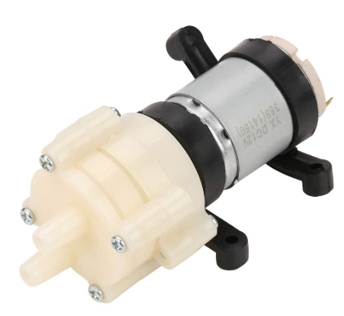

Figure 5. 10 Pump motor 385 12V DC

### Wifi module.

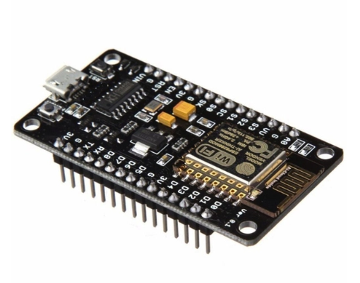The ESP8266 Wi-Fi Module, as shown in figure 5.11, is a self-contained system-on-chip (SoC) with an integrated TCP/IP protocol stack, enabling any microcontroller to connect to a Wi-Fi network. In this system, the ESP8266 is connected to the Arduino UNO via serial communication (TX/RX pins). Once the Internet connection is established, the module transmits data, including temperature, pH, and turbidity values, to the Blynk Cloud platform for remote monitoring.

Figure 5. 11 The ESP8266 Wi-Fi module.

### 4G module.

The 4G module, as shown in figure 5.12, is used to provide cellular communication capabilities for the system. It allows Arduino UNO to send and receive SMS alerts using the 4G network. In this system, A7682S is used to connect to Arduino UNO via serial communication (TX/RX pin).

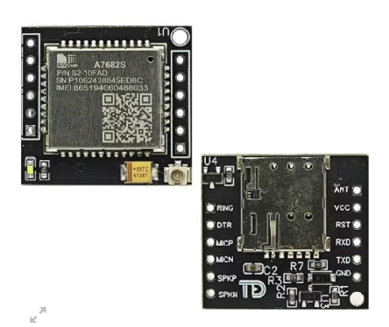

Figure 5. 12 A7682S module.

When the measured parameters such as temperature, pH, turbidity, distance and TDS exceed the pre-defined threshold value, the module will send an SMS alert to a designated phone number, ensuring that the user receives timely warnings about abnormal water quality conditions.

The A7682S 4G LTE module used in this system is compatible with all major mobile network providers in Vietnam, including Viettel, Vinaphone, and Mobifone. The module requires a stable power supply of 3.8V to 4.2V for normal operation, which is achieved through the DC-DC converter in the circuit.

### GPS module

The GPS module in figure 5.13 provides the real-time location of the monitoring station. It communicates with the ESP8266 via UART and is used to display longitude and latitude on the blynk dashboard.

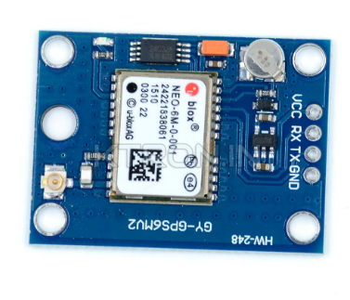

Figure 5. 13

### Power Supply.

The power supply module provides the necessary voltage and current to operate the entire system. In this system, a DC-DC converter (LM2596) in figure 5.14 is used to step down the voltage from a 12V power source to 5V, ensuring compatibility with the components.

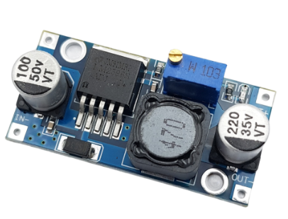

Figure 5. 14 DC Voltage Reduction Circuit LM2596.

## Software design.

### Drawing the schematic.

From the components in section 5.2, figure 5.15 is the circuit diagram of the system drawn on proteus software.

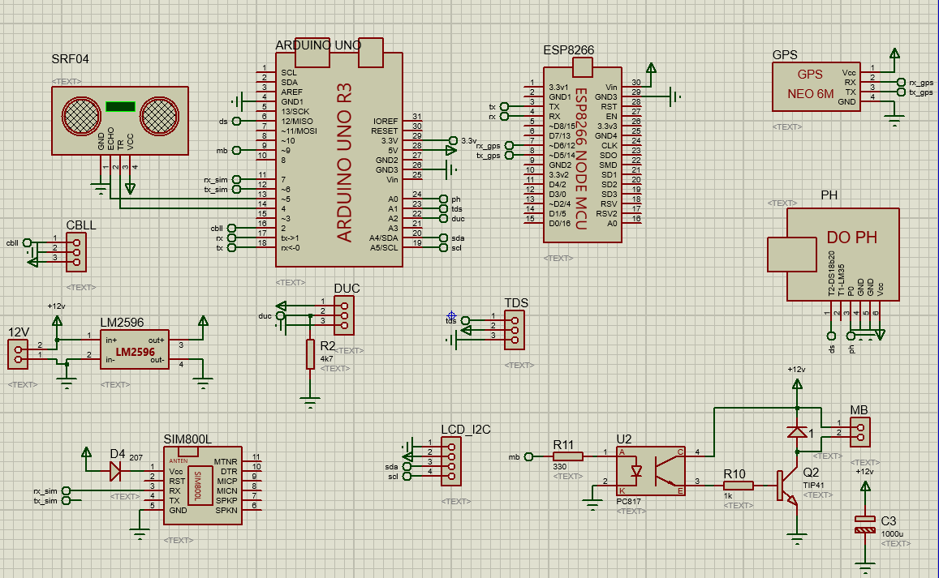

Figure 5. 15 Schematic of the system on Proteus software.

### Blynk.

Blynk is an Internet of Things (IoT) platform that enables users to create custom mobile dashboards for monitoring and controlling hardware systems via IOS and Android devices. After downloading the Blynk application, users can design a virtual interface using various widgets such as buttons, sliders, and gauges. These widgets interact with the hardware through virtual pins, allowing for real time data display and control. In this project, the Blynk app is used to display real time sensor data collected from the water monitoring system. The following parameters are visualized:

Temperature, measured by the DS18B20 sensor.

pH level, measured by the analog pH sensor.

Turbidity, indicating water clarity, measured by the turbidity sensor.

Water level measured using the ultrasonic sensor (SRF04).

Total dissolved solids (TDS), indicating water quality in ppm.

Flow rate, calculated from the pulse-based flow sensor.

Geographic location, obtained from the GPS module.

These values are sent from the ESP8266 Wi-Fi module to the blynk cloud and then retrieved by the app for live display.

## Proposed model

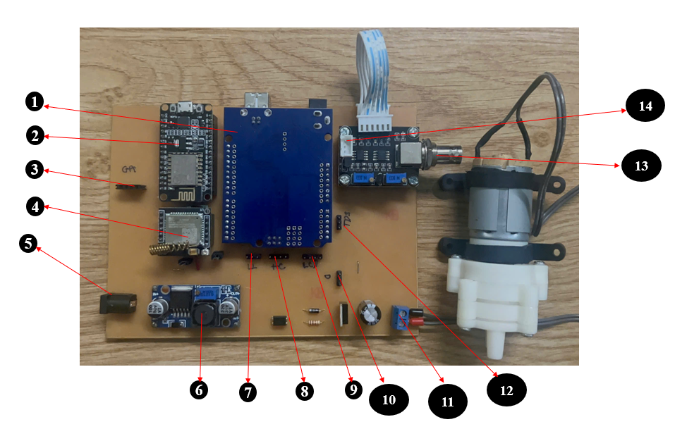Figure 5.16 shows the proposed model of the IoT-based applications for water resource monitoring system, including main components such as sensors and the placement of components detailed on the circuit board below

Figure 5. 16 Proposed model

1. Arduino UNO R3
2. Wifi module (ESP8266)
3. GPS module
4. 4G module (A7862S)
5. Power jack
6. DC-DC converter (LM2596)
7. Flow sensor
8. Ultrasonic sensor (HC-SRF04)
9. LCD display
10. Turbidity sensor
11. Pump
12. TDS sensor
13. pH sensor
14. Temperature sensor (DS18B20)

# EXPECTED RESULTS

In this chapter, we will show the results of this project.

## Results

### Hardware design.

Figure 6.1 is the complete hardware design with all sensors and components.

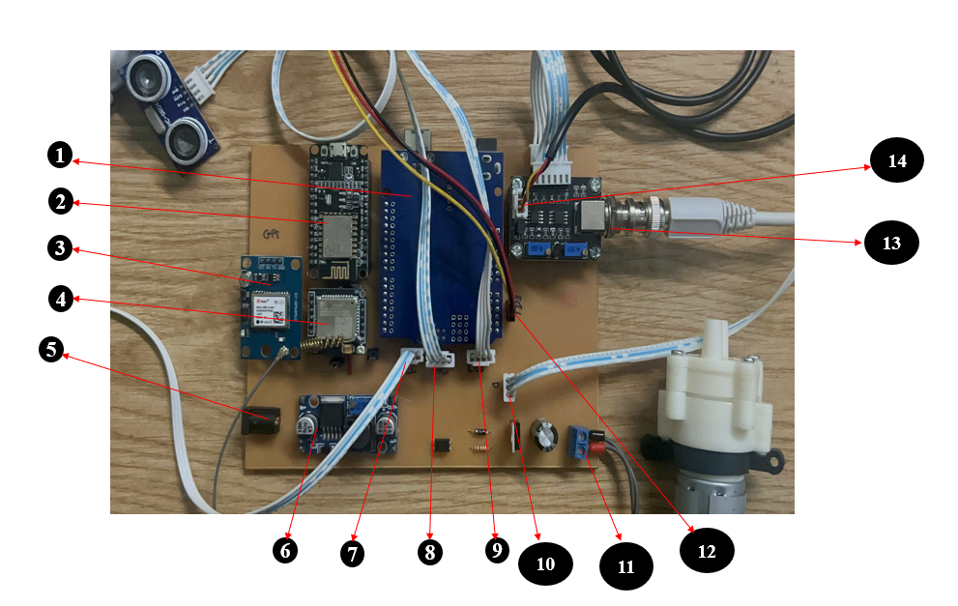

Figure 6. 1. Hardware system.

1. Arduino UNO R3
2. Wifi module (ESP8266)
3. GPS module
4. 4G module (A7862S)
5. Power jack
6. DC-DC converter (LM2596)
7. Flow sensor
8. Ultrasonic sensor (HC-SRF04)
9. LCD display
10. Turbidity sensor
11. Pump
12. TDS sensor
13. pH sensor
14. Temperature sensor (DS18B20)

### Software design.

#### Blynk app.

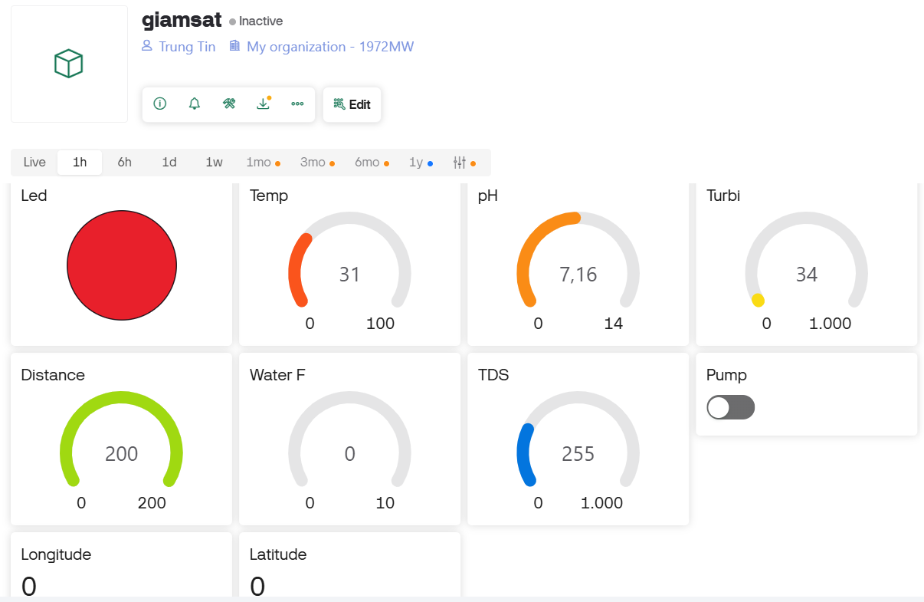Figure 6.2 shows the Blynk application interface on a smartphone, displaying the measured parameters from the system such as pH, temperature, water level turbidity, TDS and water flow. The longitude and latitude are read from the GPS module and a pump control switch. These values ​​are updated in real time via a Wi-Fi connection. In addition, an alarm is also triggered when the parameters exceed the safety threshold, indicated by a red LED on the control panel.

Figure 6. 2 Blynk application interface on smartphone.

#### System boot.

When the system starts, the LCD screen will display the message "INIT SIM... PLEASE WAIT..." (Figure 6.3) to signal that the system is checking and initializing the connection with the 4G module.

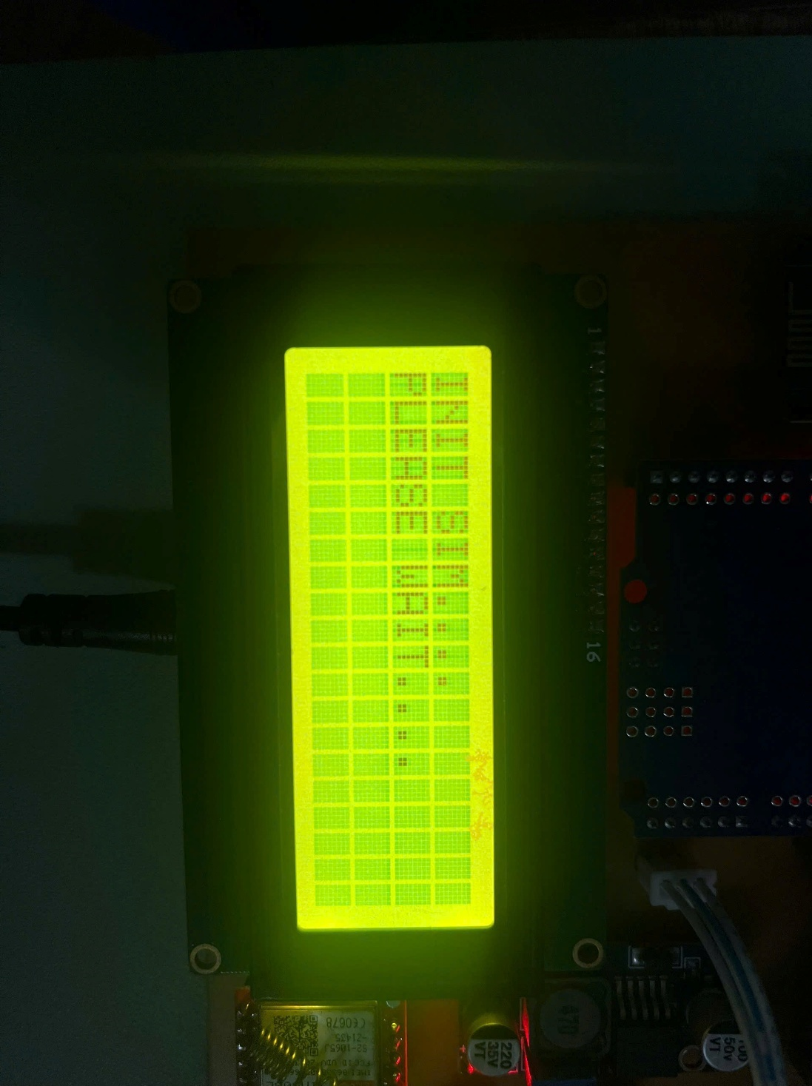

Figure 6. 3 LCD display

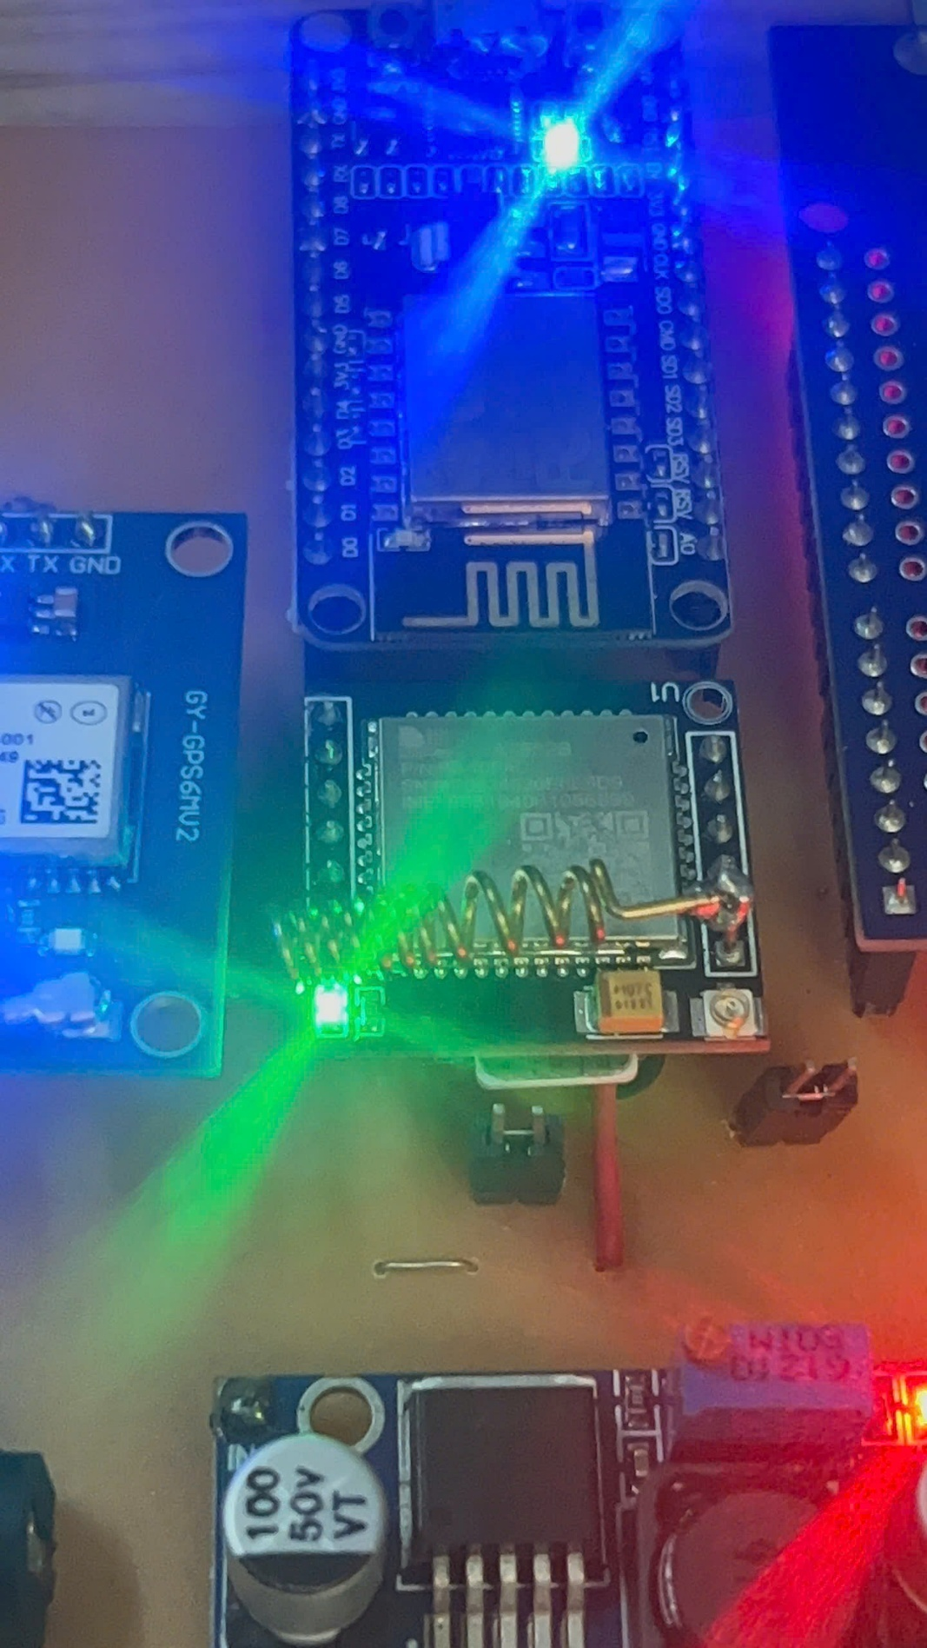If the connection is successful, the flash light on the 4G module will blink. (Figure 6.4)

Figure 6. 4 4G module in operating state.

and a message “START SUCCESSFUL” will be sent to the predetermined phone number, along with the parameters measured from the sensors at that time (Figure 6.5).

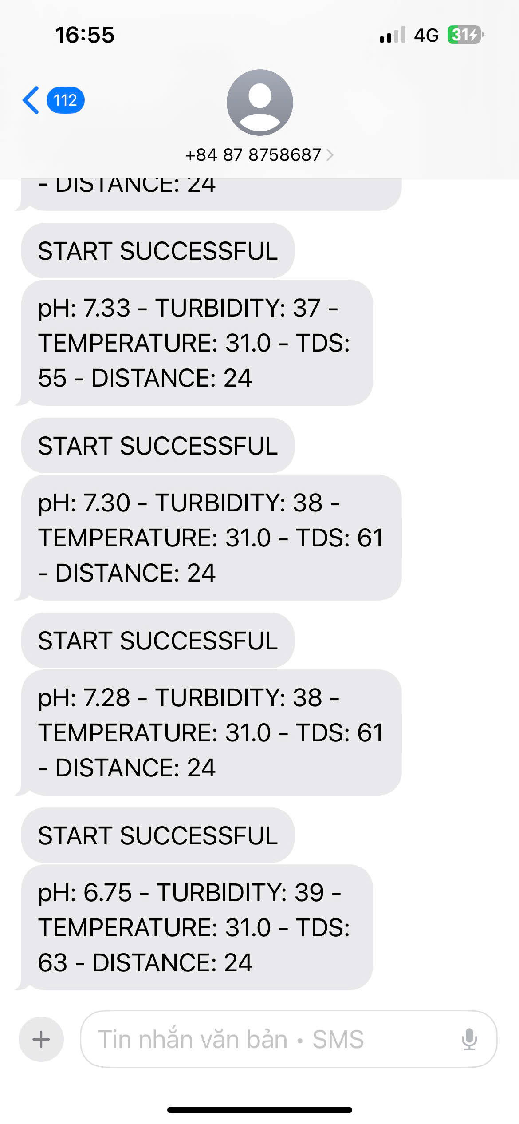

Figure 6. 5 SIM connection success notification and sensor data.

For Wi-Fi network connection, the ESP32 module plays a role in ensuring the connection between the system and the Blynk application. When the ESP32 module successfully connects to the Wi-Fi network and the Blynk application on the phone, the light on the module will light up, indicating the operating status (Figure 6.6).

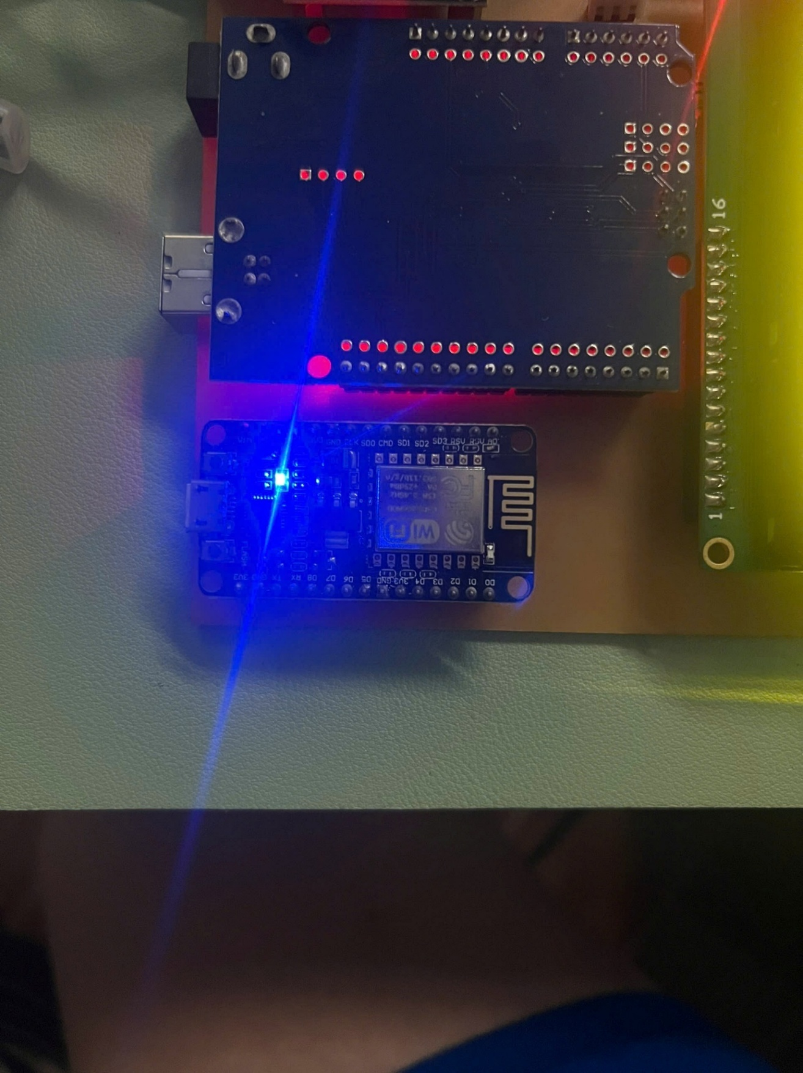

Figure 6. 6 ESP32 module successfully connects to the Wi-Fi network.

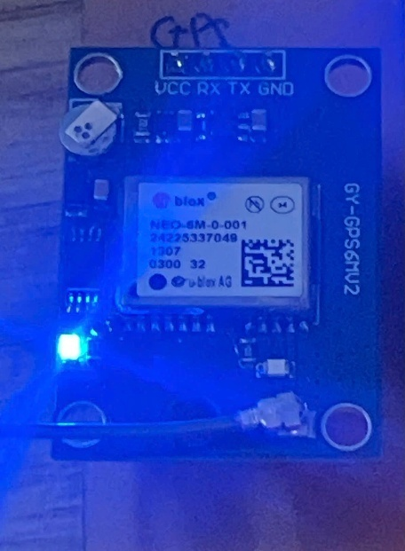For the 4G module, when the antenna captures the coordinates, the flash light on the module will blink as shown in figure 6.7.

Figure 6. 7 GPS module connected successfully

At the same time, the latitude and longitude are also sent to the blink app and a google link is displayed on the terminal as shown in figure 6.8.

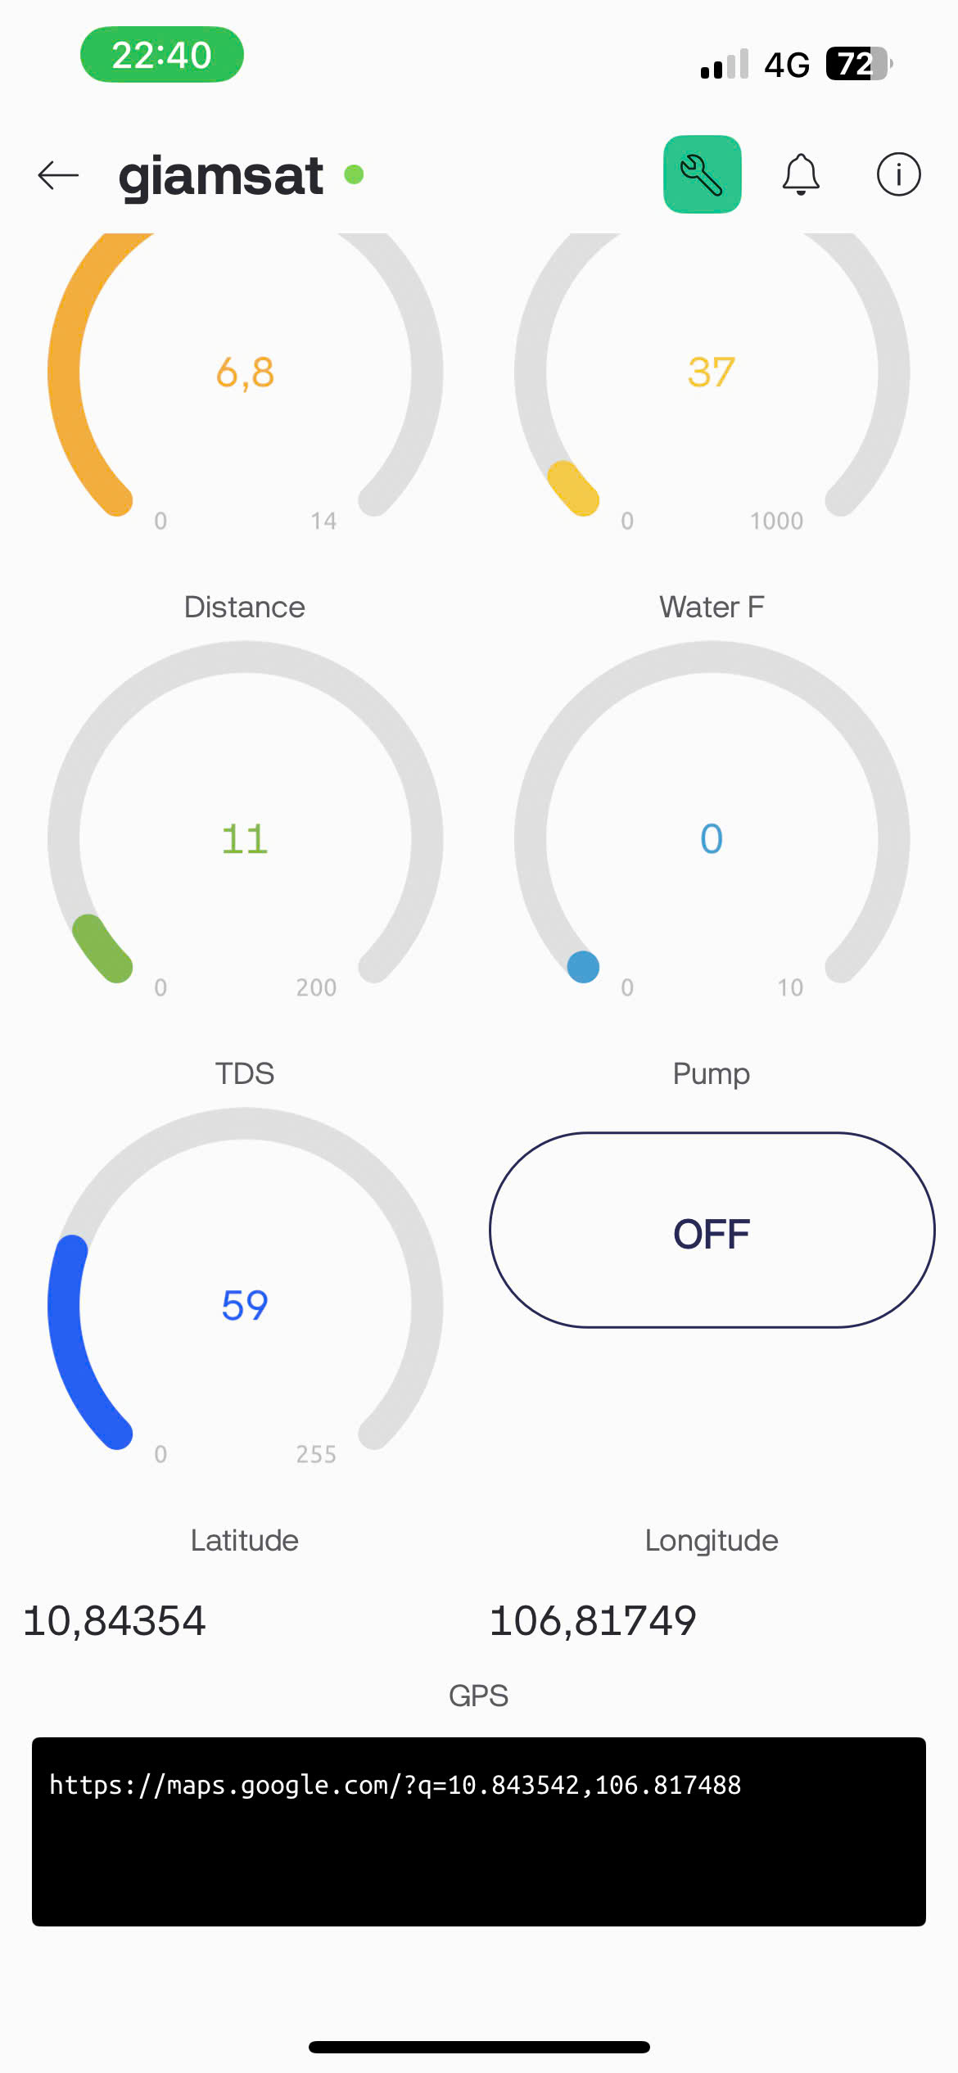

Figure 6. 8 Real time GPS coordinates and location link displayed on Blynk app

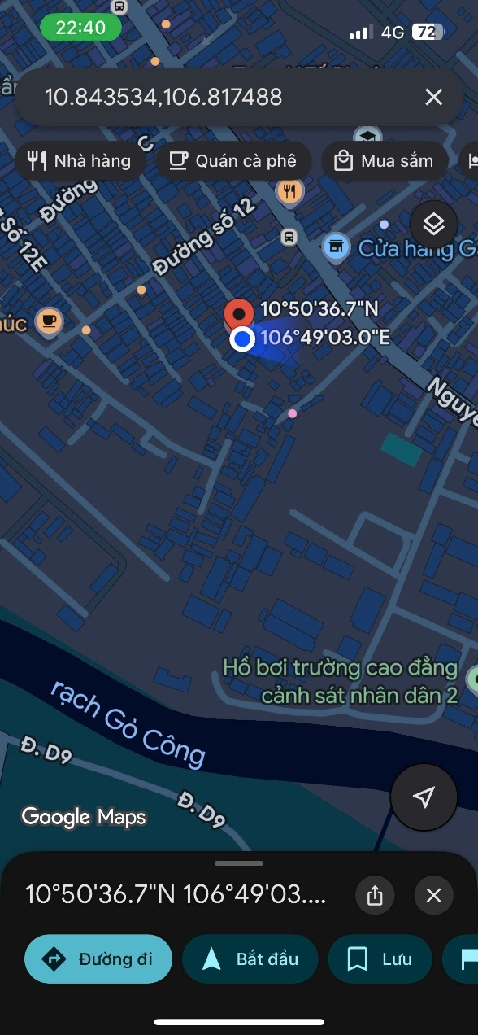When clicking on the link and selecting show on map, it will automatically switch to google map and show the location where the system is located. This is illustrated in figure 6.9

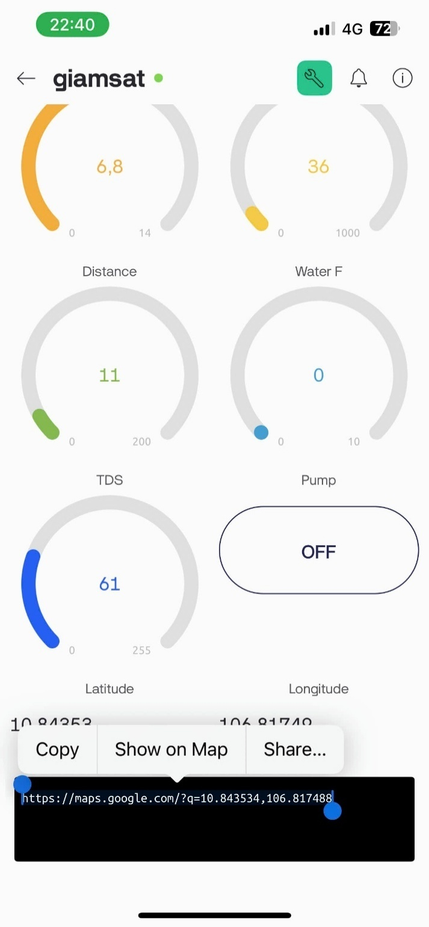

Figure 6. 9 GPS link from blynk app and location on google maps

At that time, the Blynk application will start receiving and directly displaying parameters from the sensors, including pH, temperature, turbidity, TDS, water level and water flow (Figure 6.10).

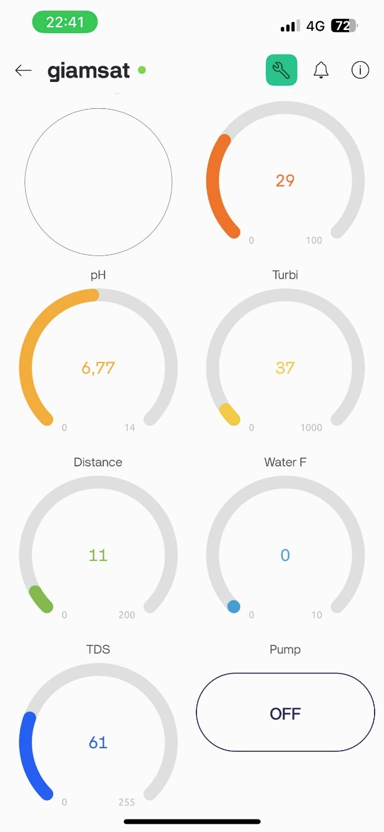

Figure 6. 10 Blynk application interface displaying sensor parameters.

### Evaluate the system performance in different environments.

The water quality monitoring system was tested in different environments to evaluate the accuracy of the sensors measuring pH, temperature, turbidity and water level. Among the measured parameters, pH is the most important, to create a neutral, acidic, basic water environment. I used a pH correcting powder (Figure 6.11).

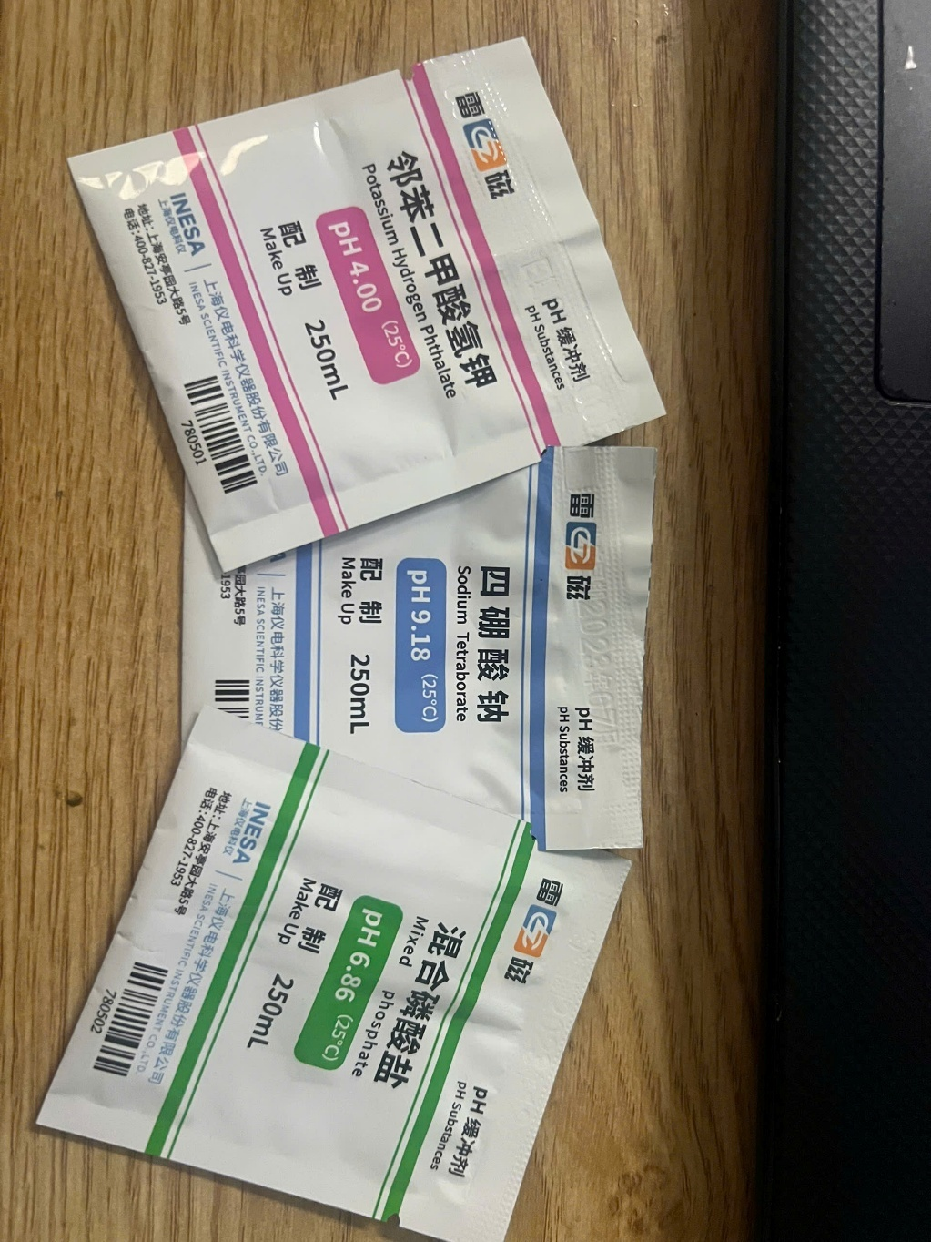

Figure 6. 11 pH correction package.

With pH parameters provided by the manufacturer as shown in table 6.1

Table 6. 1 pH correction package specifications

|  |  |  |  |
| --- | --- | --- | --- |
| **oC** | **pH4.01** | **pH6.86** | **pH9.18** |
| 10 | 4.00 | 6.92 | 9.33 |
| 15 | 4.00 | 6.90 | 9.28 |
| 20 | 4.00 | 6.88 | 9.23 |
| 25 | 4.01 | 6.86 | 9.18 |
| 30 | 4.01 | 6.85 | 9.14 |
| 35 | 4.02 | 6.84 | 9.10 |
| 40 | 4.03 | 6.84 | 9.07 |
| 45 | 4.04 | 6.83 | 9.04 |
| 50 | 4.06 | 6.83 | 9.02 |

To check the accuracy of the system after calibration, I conducted tests in three specific cases, corresponding to three different environments:

Acidic environment: pH about 4.

Neutral environment: pH about 6.

Basic environment: pH about 9.

#### Case 1: Acidic environment: pH about 4.

In the first test, water with a low pH (around 4) was tested. The system measured a value of 4.02, which matched the results from the litmus test, confirming the accuracy of the sensor. Illustrative image of the test:

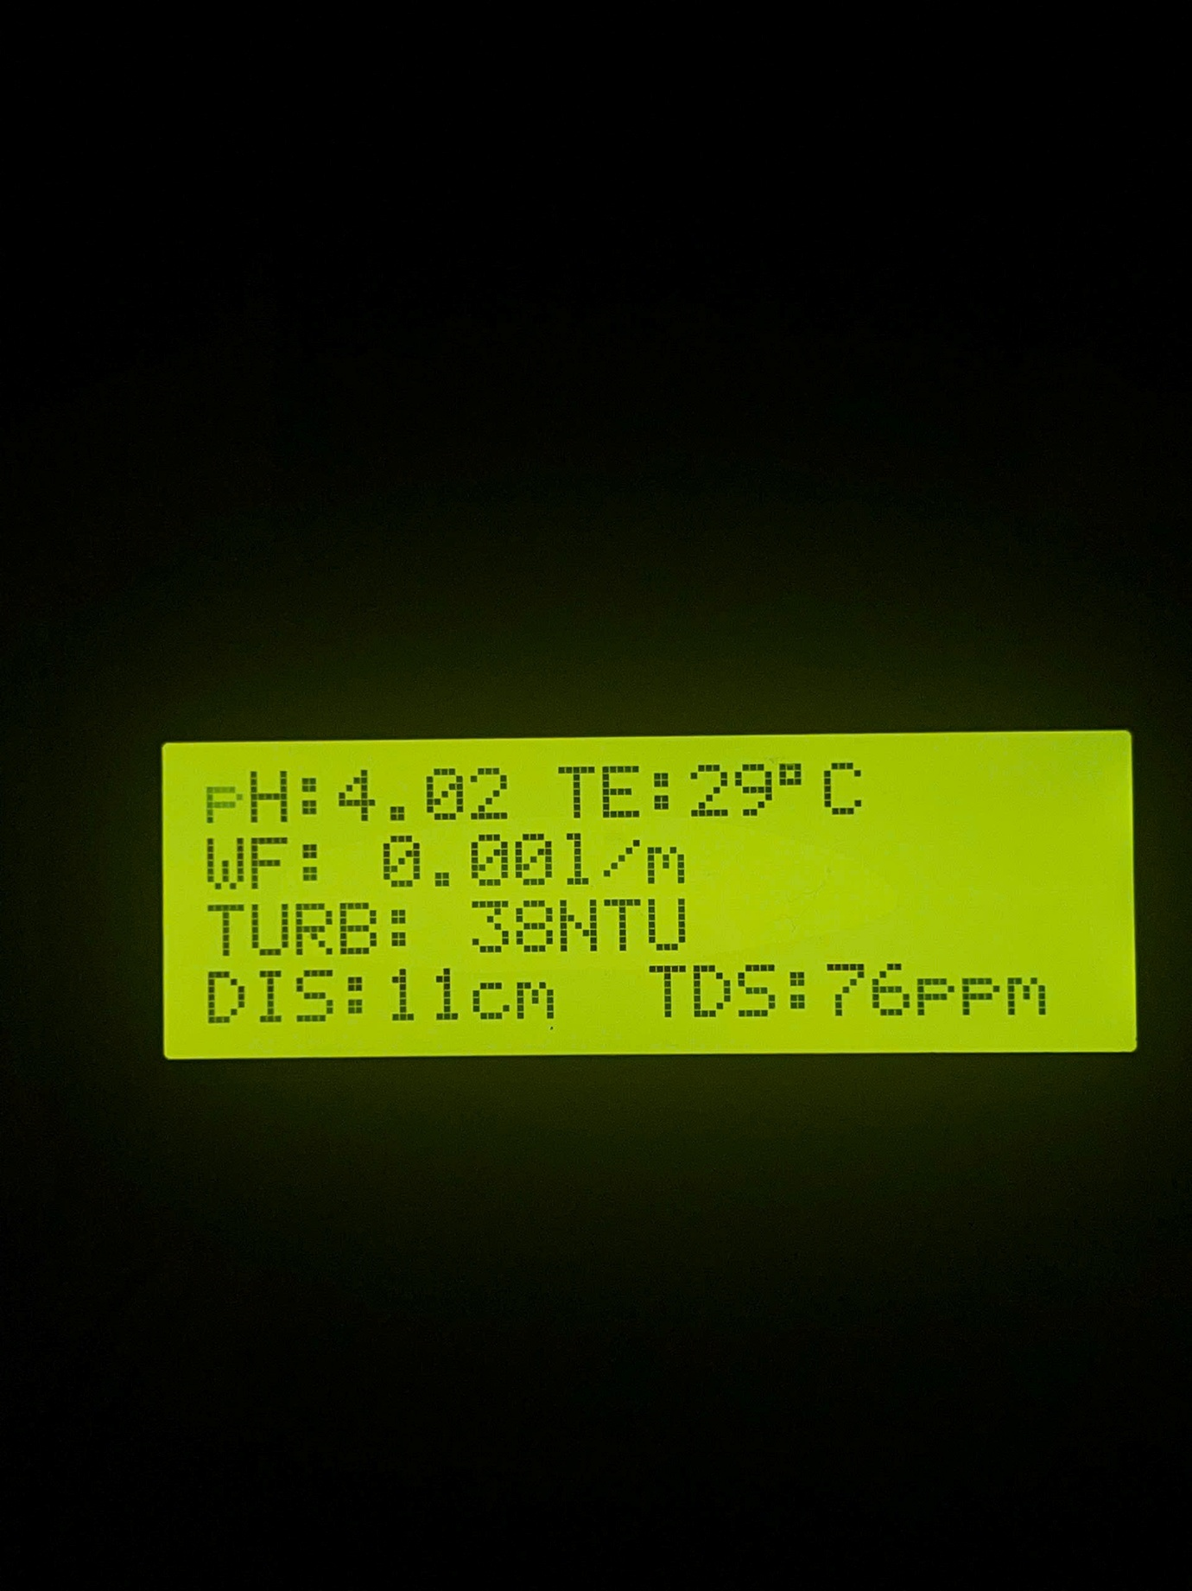

Figure 6. 12 Hardware system when operating with low pH water samples.

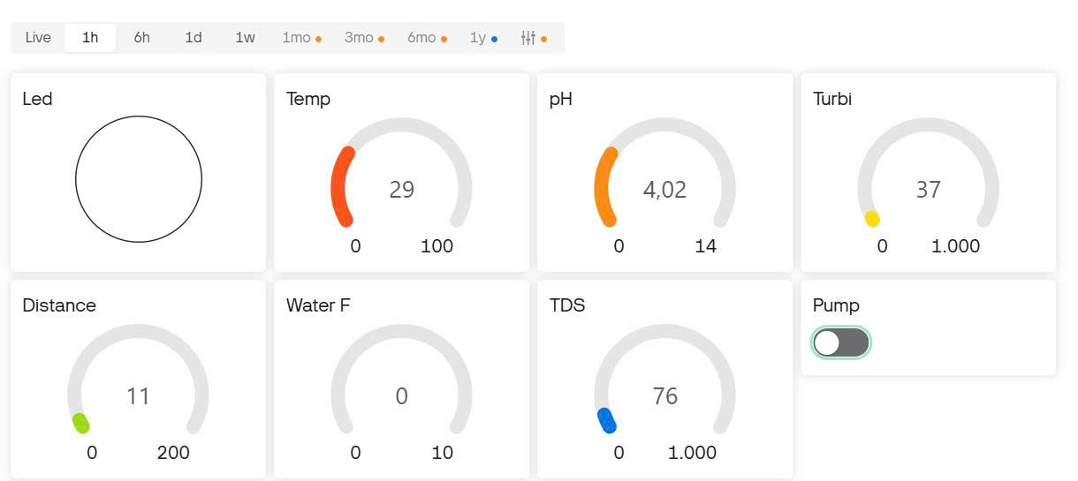

Figure 6. 13 Blynk interface shows pH measurement result is 4.02 with other indicators

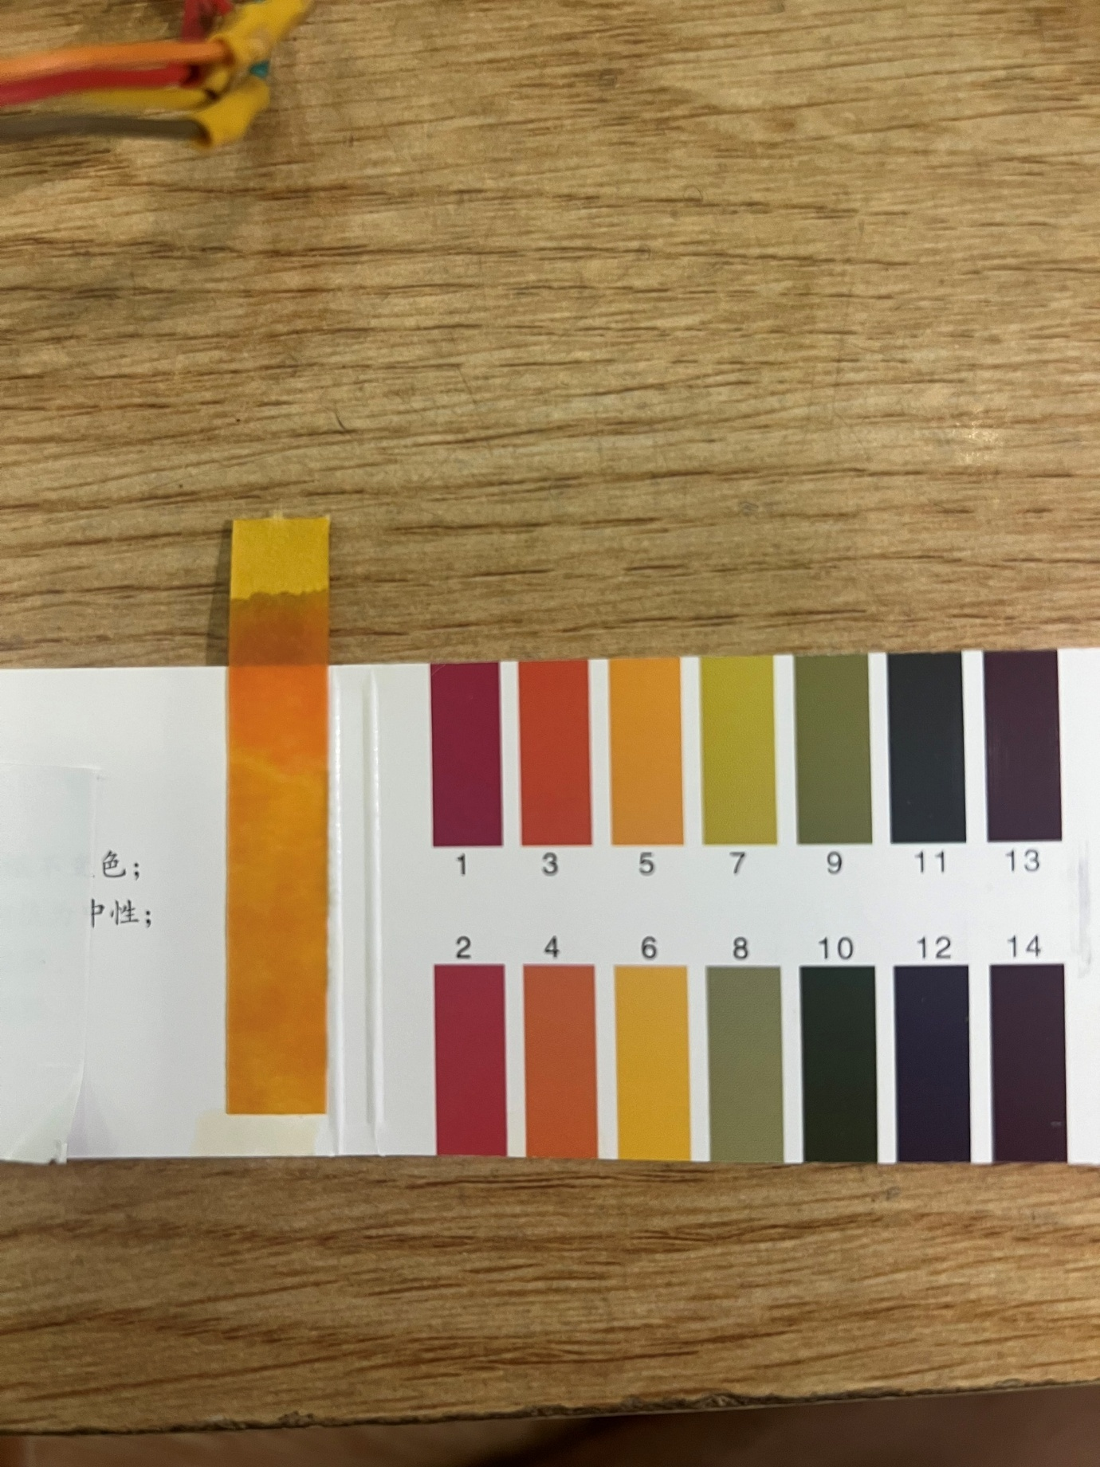

Figure 6. 14 The litmus test results showed that the pH was at 4.

#### Case 2: Neutral environment: pH about 6.

In the second case, water with a neutral pH (around 6.) was measured and the value returned from the system was 6.96, which is close to the litmus test result, confirming the accuracy of the sensor. Illustrative image of the test

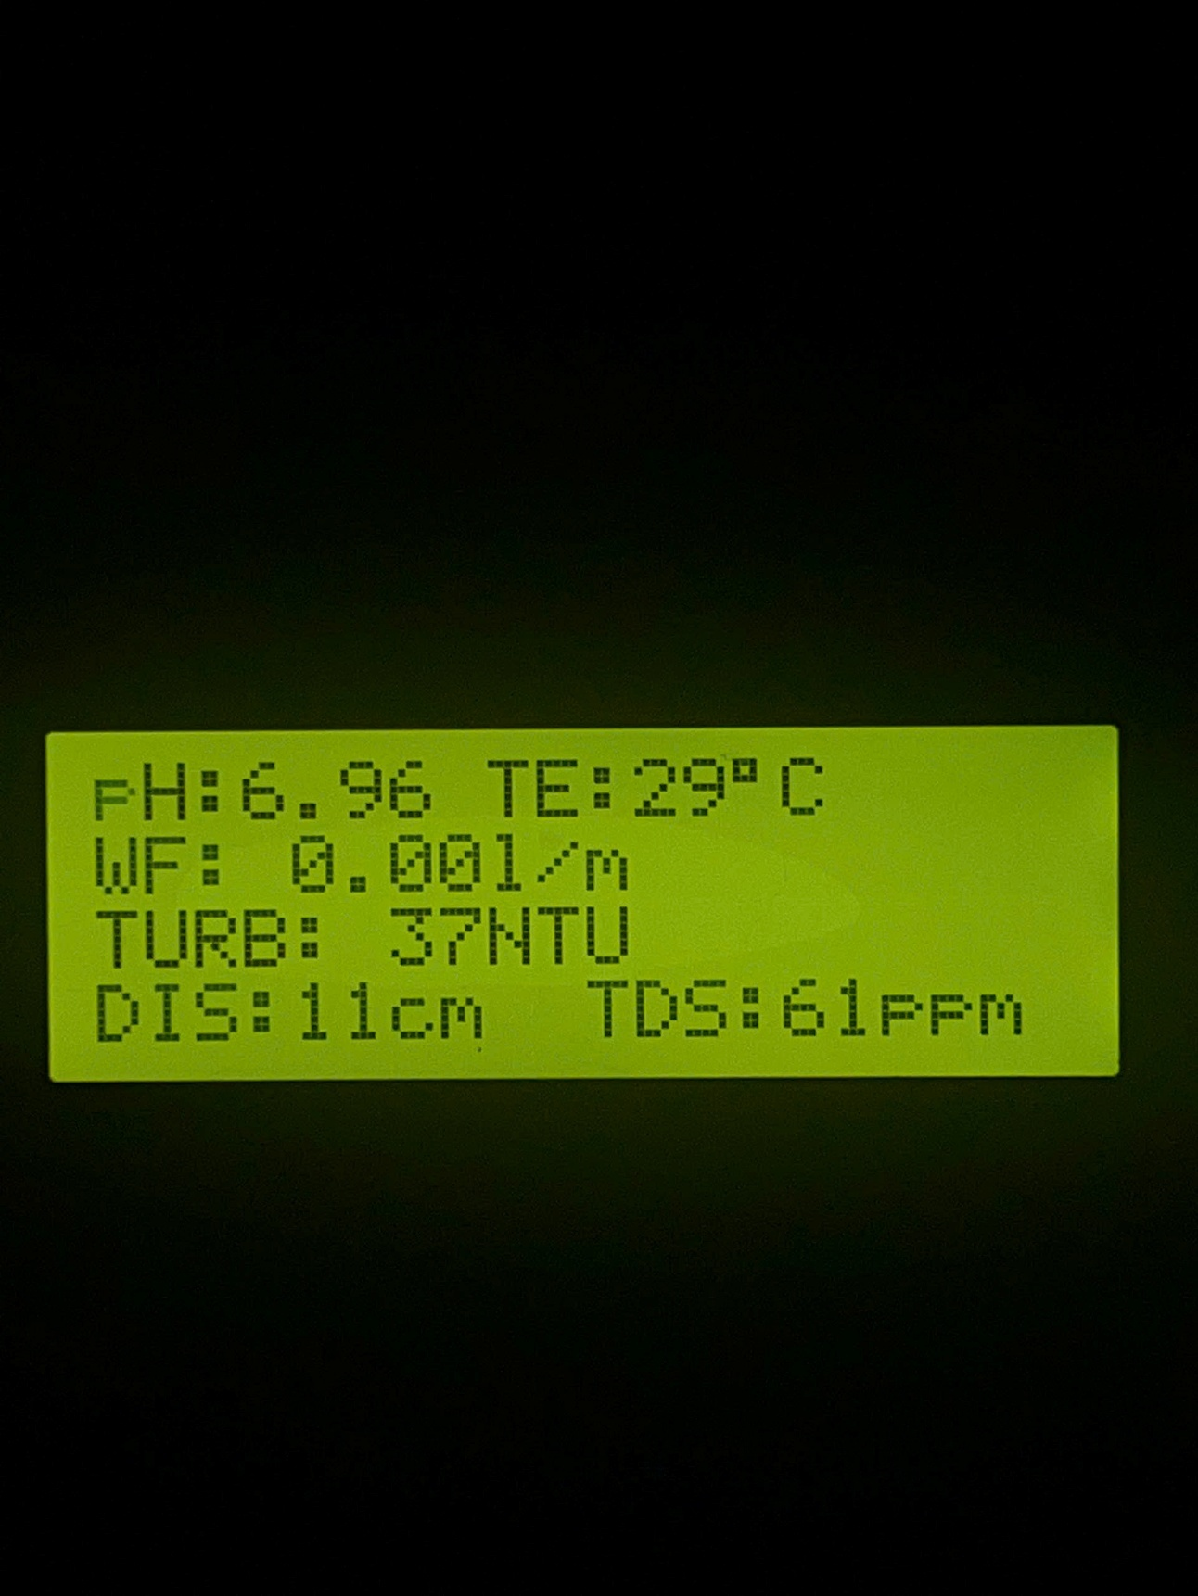

Figure 6. 15 Hardware system when operating with pH = 6.96 water samples.

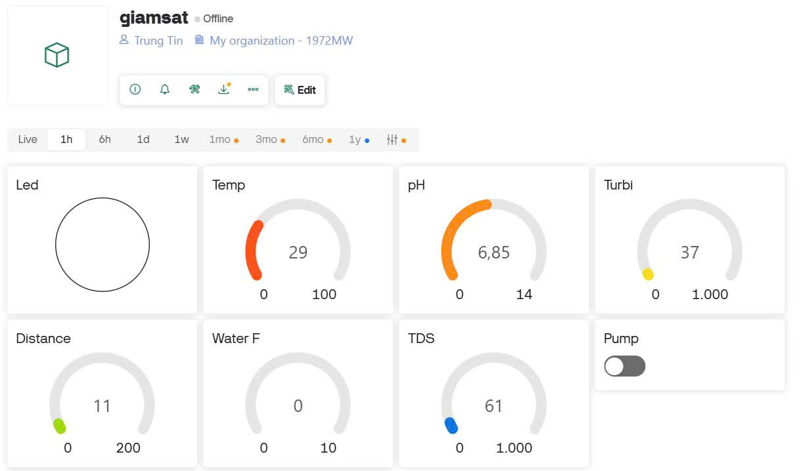

Figure 6. 16 Blynk interface shows pH measurement result is 6.85 with other indicators

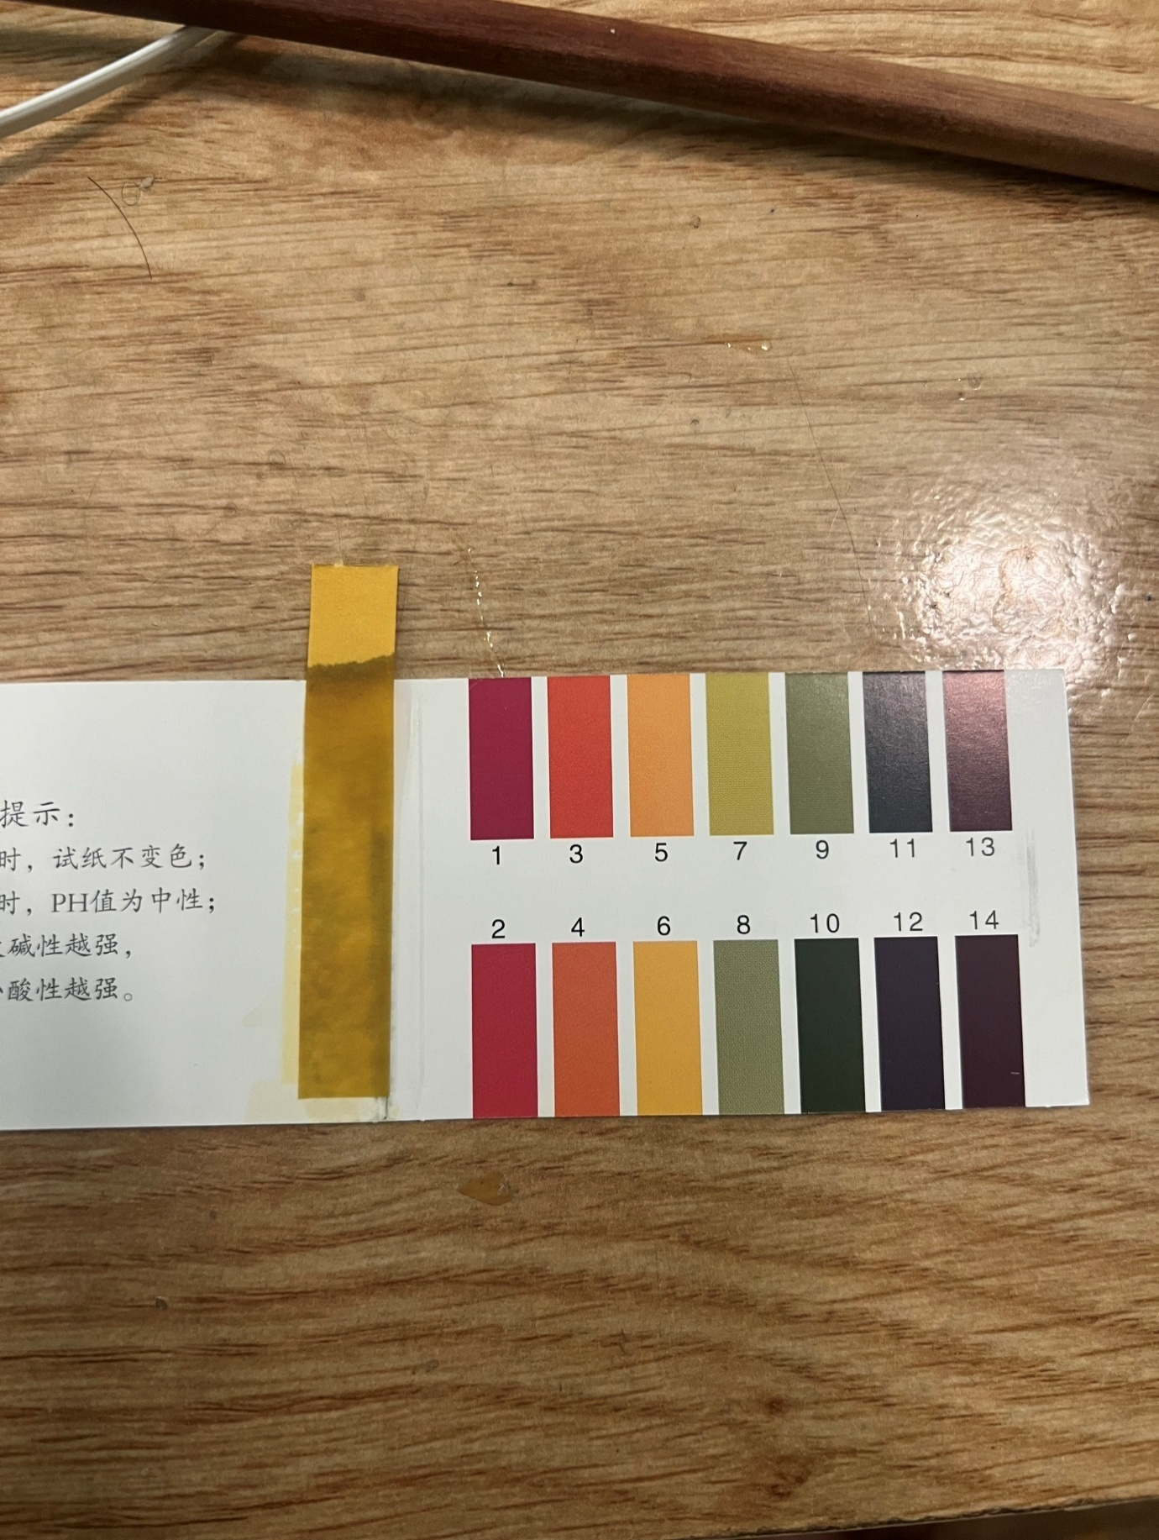

Figure 6. 17 The litmus test results showed that the pH was at 6

#### Case 3: Basic environment: pH about 9.

In the first case, water with a high pH (above 9) was measured and the value returned from the system was , which is close to the litmus test result. Illustrative image of the test:

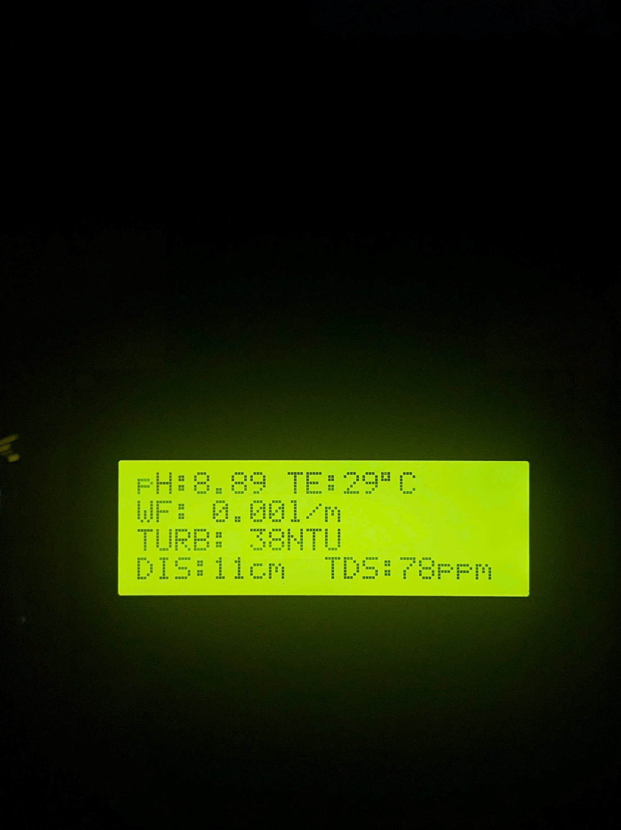

Figure 6. 18 Hardware system when operating with high pH water samples

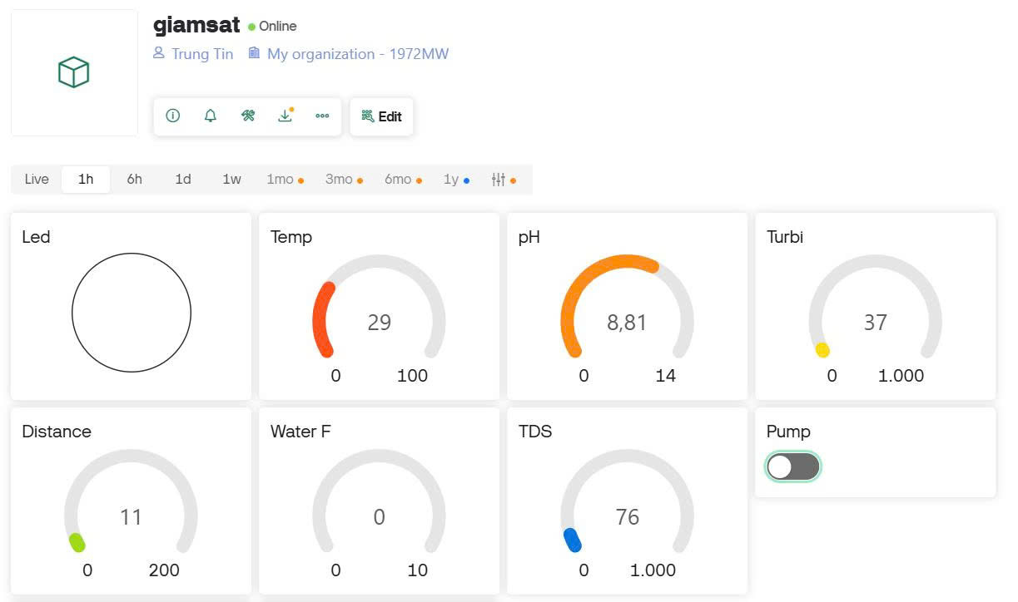

Figure 6. 19 Blynk interface shows pH measurement result is 8.81 with other indicators

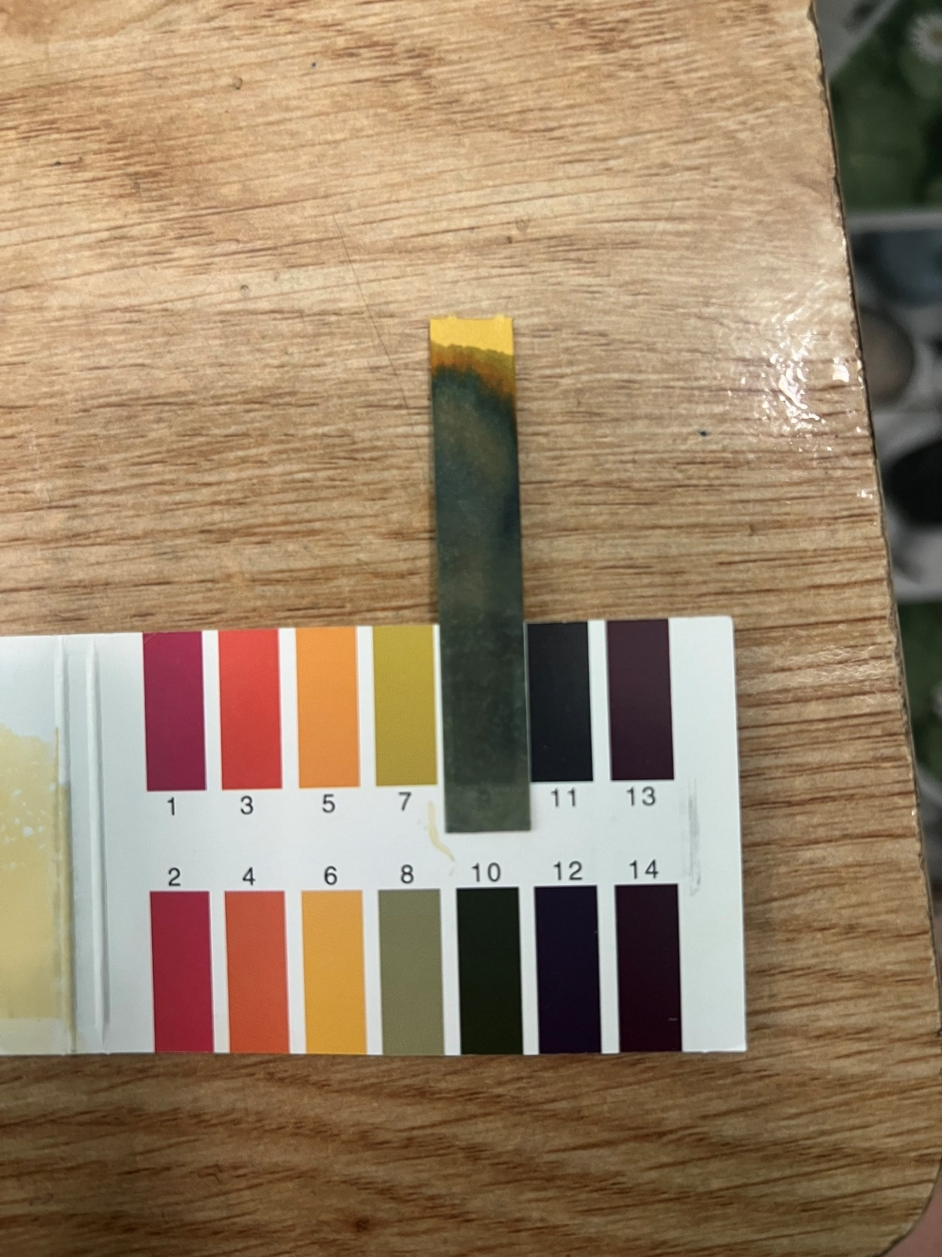

Figure 6. 20 The litmus test results showed that the pH was at 10

### Flow rate measurement results

To calculate the water flow in liters per minute (l/m), the formula used in the program is as follows

$$water flow= \frac{x×60}{encoder}$$

Where

* Water flow is the water flow in liters/minute (l/m)
* x is the number of pulses measured in 1 second
* 60 is the conversion factor from seconds to minutes (1 minute = 60 seconds)
* Encoder is the number of pulses corresponding to 1 liter of water

I have calculated the encoder coefficient according to the following process. The system uses a 385 12VDC pump motor and a YF-S401 sensor as in section **5.2.6**, using an additional 8mm water pipe and a 1 liter water measuring bottle. Count the pulses for 1 liter of water: let the pump operate and the flow sensor will start counting pulses until the bottle has enough 1 liter of water, then stop. Doing this 10 times in a row, I got the results in table 6.2 below.

Table 6. 2 Number of pulses measured per liter in 10 calibration runs

|  |  |
| --- | --- |
| Number of measurements | Pulses/liter results |
| 1 | 2977 |
| 2 | 2984 |
| 3 | 2946 |
| 4 | 2940 |
| 5 | 2943 |
| 6 | 2984 |
| 7 | 2979 |
| 8 | 2937 |
| 9 | 2927 |
| 10 | 2952 |

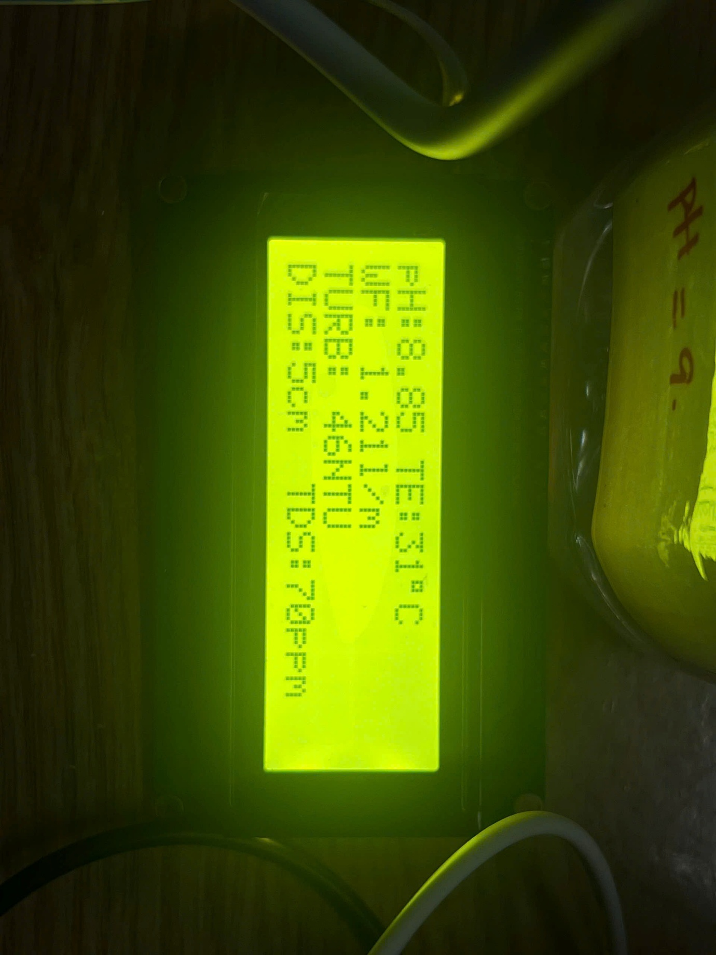Encoder average value = 2957 pulses/l

Using the encoder coefficient in the actual water quality monitoring system, the system pumps water for 1 minute and the result on the LCD display is 1.21 l/m in figure 6.21 That means in 1 minute the system has pumped 1.21 liters of water. The result is almost exactly the same as the capacity of the 385 pump motor.

Figure 6. 21 LCD display with WF = 1.21 l/m

### Warning system test results.

About SMS alert system and red LED alert on blynk app illustrated in two cases below are turbidity and distance

#### Turbidity warning exceeds 500 NTU

When the turbidity value exceeds the warning threshold exceeds 500 NTU (689 NTU), the warning LED turns red (figure 6.22) to attract attention.

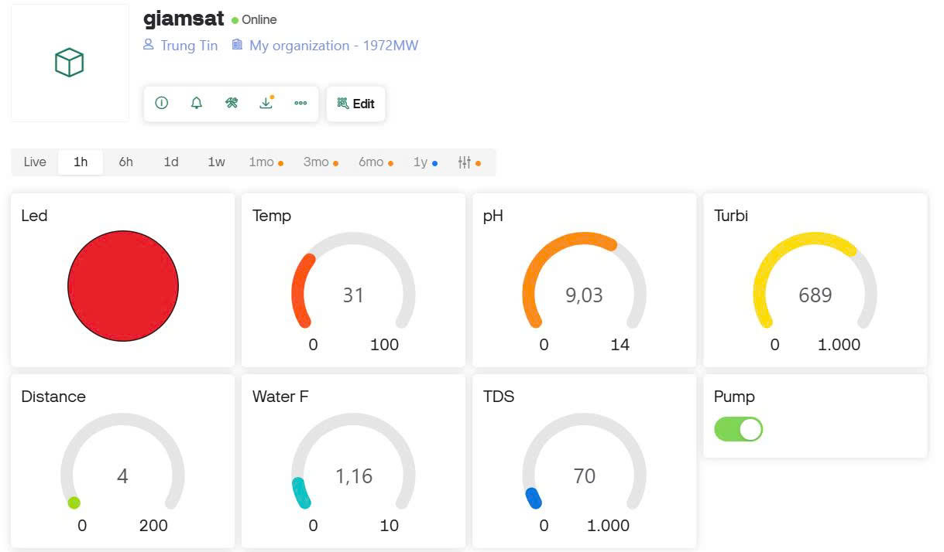

Figure 6. 22 Turbidity alert on Blynk

Warning sent via sms using 4G module with turbidity value: 619 NTU in figure 6.23

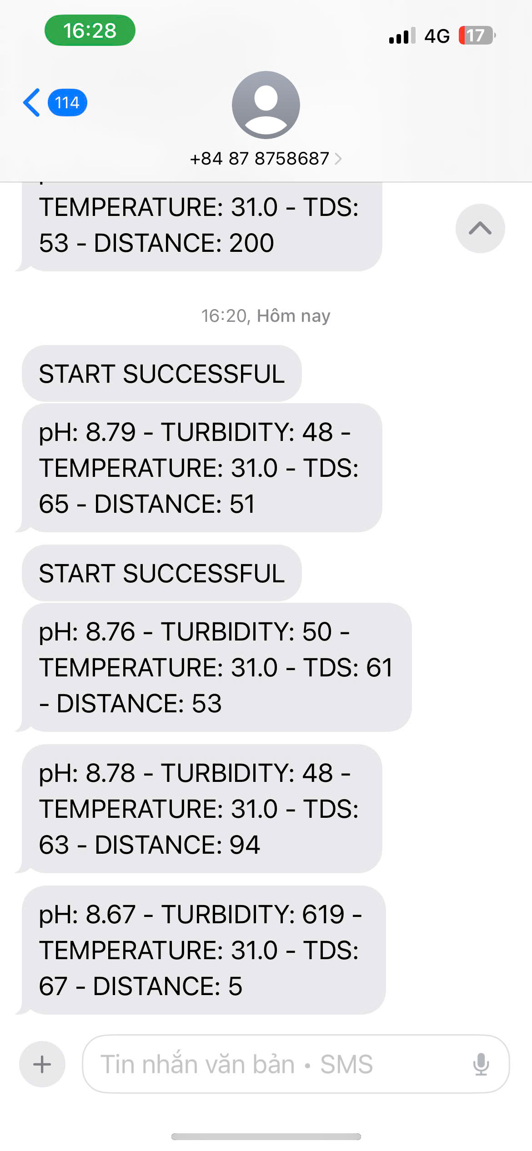

Figure 6. 23 SMS alert with turbidity: 619 NTU

#### Distance warning exceeds 60

When the distance value exceeds the warning threshold exceeds 60 (200), the warning LED turns red (figure 6.24) to attract attention.

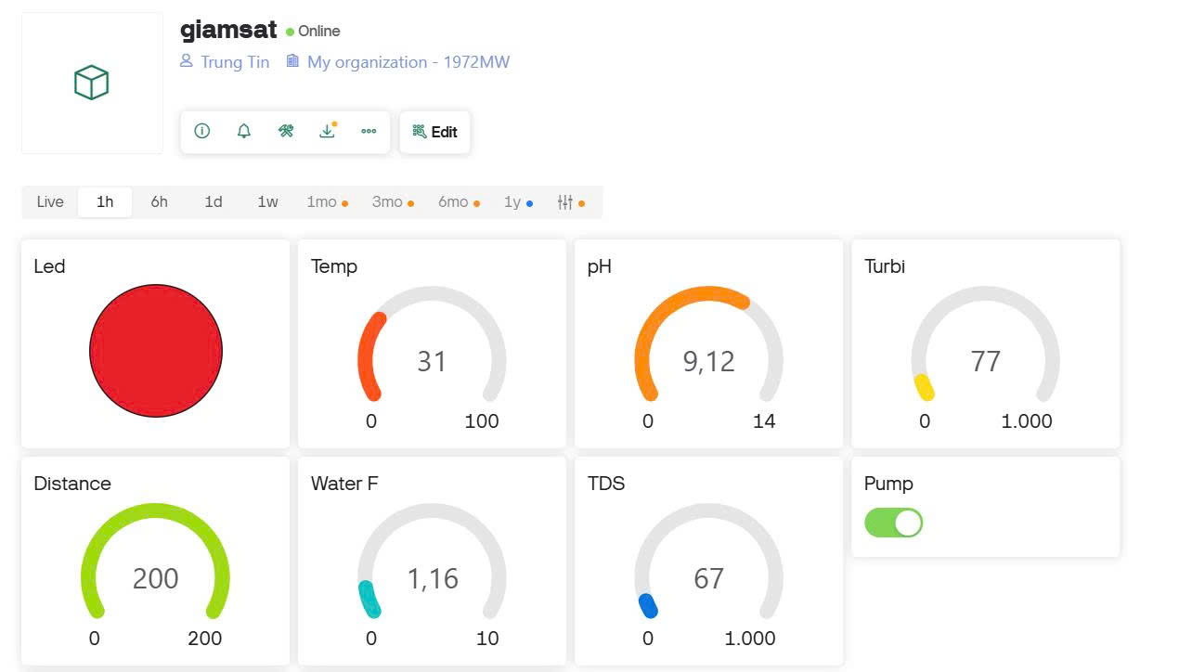

Figure 6. 24 Distance alert on Blynk

Warning sent via sms using 4G module with distance value: 200 in figure 6.25

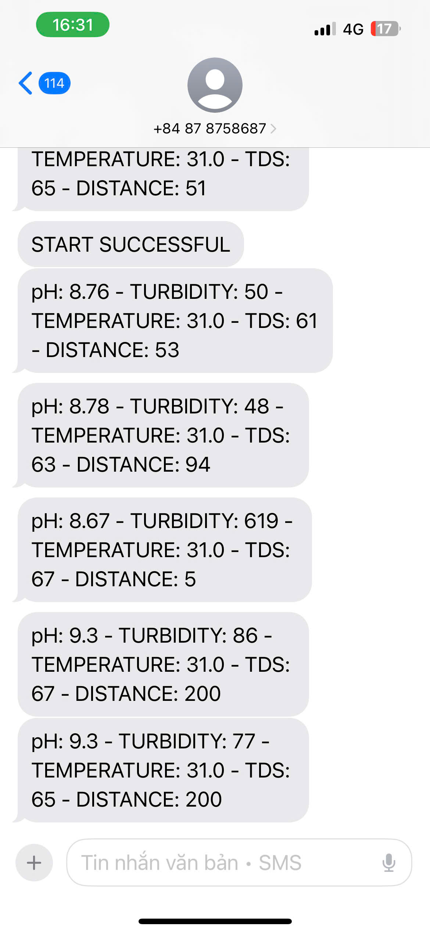

Figure 6. 25 SMS alert with distance: 200

## Discussions

The above results demonstrate the stability of the system. The measured parameters including temperature, pH, turbidity, TDS, water level, flow rate and GPS location are continuously transmitted and displayed in real time on the Blynk application. For example, the pH measured for the environment is approximately the same as the pH calibration package. The TDS values ​​range from 50 to 600 ppm, indicating the water hardness in each environment, supported by the classification in Figure 5.7. The temperature reading, recorded at 29 to 33 °C, is typical for ambient water under normal conditions. The system also effectively triggered alerts through the Blynk virtual LED and SMS messages when thresholds were exceeded. For instance, when turbidity surpassed 100 NTU, the dashboard displayed a red LED and a message was sent via the A7682S 4G LTE module, showing that the warning mechanism was functional and responsive.

Compared to the previous studies referenced in Chapter IV, this system offers several improvements: integration of more sensors (including GPS and TDS), dual communication methods (Wi-Fi and 4G) and integrated real time control via mobile application. Particularly the replacement with 4G module when the system of Kavita Katole, Yashoj Narnaware [9] section 4.1.1 uses 2G sim module which is completely cut off in Vietnam. The ability to monitor flow through pulse-based sensors has added an additional layer of understanding to detect abnormal water usage.

# CONCLUSIONS AND FUTURE WORK

## Conclusions.

During this senior project, I have gained extensive knowledge and practical experience in developing an IoT-based water quality monitoring system. This includes learning about integrating sensors such as DS18B20 (temperature sensor), pH sensor, turbidity sensor, and ultrasonic sensor with Arduino UNO microcontroller. We also developed skills in using ESP8266 and GSM module for wireless communication and data transmission.

Furthermore, this project also provided me with practical experience in circuit design, as well as practical techniques in assembling and testing hardware systems. I have also improved my skills in working with Blynk IoT platform to create a user-friendly interface for remote monitoring and management.

Although the current system is stable, there are still parts that need to be optimized and improved. In the future, I will improve the efficiency of the system, expand the monitoring capabilities by adding more sensors, and improve the reliability of communication channels to ensure seamless operation in various environments.

## Future work.

An IoT-based water quality monitoring system has been successfully developed to measure parameters such as temperature, pH, turbidity, and water level. While the current system meets the main goals of real-time monitoring and remote access, there are still limitations that need to be addressed. For example, the system’s reliance on Wi-Fi to transmit data to the cloud can be problematic in areas with unstable Internet connections. The accuracy of some sensors could be further optimized to be able to identify clean, polluted, or highly polluted water.

In the future, to expand the system for broader applications such as aquaculture monitoring and household water safety, I would like to see some improvements. First, improving the accuracy and stability of the main sensors, especially for pH, turbidity and TDS, would allow the system to better classify water conditions as clean, polluted or highly polluted. Second, integrating additional sensors such as dissolved oxygen and salinity sensors, to provide a more comprehensive assessment of water quality. This classification is essential for both aquatic health and public safety. Finally, another potential improvement involves applying AI-based analytics to predict water quality and provide proactive alerts, ensuring timely intervention.

# BUSINESS, SOCIAL AND ETHICAL CONSIDERATIONS

## Business considerations

The proposed IoT-based water quality monitoring system demonstrates strong potential for real-world application in various business sectors, particularly in environmental services, agriculture, aquaculture, and rural infrastructure development. Its relatively low cost, modular design, and ability to provide real-time data make it feasible for commercialization, especially in markets that require scalable and affordable monitoring solutions.

## Social considerations

This system is useful in daily life, especially in rural or low-income areas where people rely on wells, rainwater or rivers for their daily water use. The system helps detect unsafe water sources early and alerts users when water quality is poor, helping to protect health and prevent diseases. In fish or shrimp farming, the system can monitor water conditions such as pH, turbidity and temperature, and alert farmers when the values ​​are out of range, increasing productivity. Because it uses simple components and works with mobile phones, the system is easy to use, low cost and suitable for many different places. The system supports access to clean water and helps people take good care of their water resources and the environment.

## Ethical considerations

This project did not involve any people or animals in testing, and no personal information was collected. The hardware and software used are open-source and safe for learning and development. In the future, if the system is used in communities or public areas, it is important to use the data carefully. People should know how the data is used, and alerts must be clear and correct to avoid confusion. The system should always be used to help improve water quality and protect public health.

# REFERENCES

[1]. https://doctorhouses.com/tam-quan-trong-cua-nuoc-va-giai-phap-cuu-nguon-nuoc-sach.html

[2]. https://vtv.vn/xa-hoi/nguon-nuoc-o-nhiem-co-the-gay-ton-that-toi-35-gdp-moi-nam-20240329195002844.htm

[3]. https://www.usgs.gov/special-topics/water-science-school/science/vong-doi-cua-nuoc-water-cycle-vietnamese

[4]. Ogundele Joshua, Francis Enejo Idachaba, Onyinyechi Steve-Essi, “Design and Implementation of a Smart Water Monitoring System (IoT) Using Arduino Microcontroller”, College of Engineering, College of Engineering, Covenant University, Covenant University, 2022

[5]. S. Kavi Priya, G. Shenbagalakshmi, and T. Revathi, "Design of smart sensors for real-time drinking water quality monitoring and contamination detection in water distributed mains", International Journal of Engineering & Technology, Vol. 7, pp42-51. 2018

[6]. N. Andre Cloete, R. Malekian and L. Nair, "Design of Smart Sensors for Real-Time Water Quality Monitoring”, Journal of IEEE Access, Vol. 13, No. 9, September 2014.

[7]. P. B. Bokingkito Jr and O.E. Llantos, "Design and Implementation of Real-Time Mobile-based Water Temperature Monitoring System", Procedia Computer Science, Vol.123, pp. 698-705, 2017.

[8]. M. Pule, A. Yahya and J. Chuma, "Wireless sensor networks: A survey on monitoring water quality. Journal of Applied Research and Technology", Vol. 15, 562-570, January 2018.

[9]. Kavita Katole, Yashoj Narnaware, Banshikha Biswas, Dimpal Patle, “Design & Implementation of Water Quality Monitoring & Notification  
System”, International Research Journal of Engineering and Technology (IRJET), 2019.

[10]. Ogundele Joshua Iyanuoluwa, Steve-Essi Onyiyechi, Francis Idachaba, “Design and Implementation of a Smart Water Monitoring System (IoT) Using  
Arduino Microcontroller”, College of Engineering, Covenant University, 2022.

[11]. Jomsuda Duangwongsa, Thepparath Ungsethaphand, Pradchayaporn Akaboot, Supakit Khamjai, Syan Unankard, “Real-time Water Quality Monitoring and  
Notification System for Aquaculture”, The 6th International Conference on Digital Arts, Media and Technology (DAMT) and 4th ECTI Northern Section Conference on Electrical, Electronics, Computer and Telecommunications Engineering, 2021.

[12]. M. P. P. Sithole, N. I. Nwulu, E. M. Dogo, "Development of a Wireless Sensor Network Based Water Quality Monitoring and Notification System", Department of Electrical and Electronic Engineering Science, University of Johannesburg, South Africa, 2019.

[13]. Mohd Sallehin Mohd Kassim, Mohd Rifqi Rozman, Aznida Abu Bakar Sajak, Rula Alrawashdeh, "IoT Water Quality Monitoring for Smart City”, Article in International Journal of Advanced Trends in Computer Science and Engineering, September 2020.

[14]. <https://doctorhouses.com/tam-quan-trong-cua-nuoc-va-giai-phap-cuu-nguon-nuoc-sach.html>

# APPENDICES